20191107 0912 最新狀態
後台
http://www.buck4u.com/admin_lak7t5
adminmag ; frevres0907
前台一
http://www.buck4u.com/
前台二
http://www.buck4all.com/
PHPMYADMIN
http://18.218.158.219/awsadmin/
root ; revres88

都正常

設定檔
/etc/apache2/sites-available/buck4u.conf
<VirtualHost *:80>
DocumentRoot /var/www/html/magento8pm/pub/ (對應這個, 下面 setenv 才有用)
# DocumentRoot /var/www/html/magento8pm/
# DocumentRoot /var/www/html/
ServerName www.buck4u.com
ErrorLog /var/log/apache2/error_log
CustomLog /var/log/apache2/access_log common
#SetEnv MAGE_ROOT "/var/www/html/magento8pm/pub/"
SetEnv MAGE_MODE "developer"
#SetEnv MAGE_RUN_CODE "demo2"
SetEnv MAGE_RUN_CODE "default8"
SetEnv MAGE_RUN_TYPE "store"
</VirtualHost>

<Directory /var/www/html>
Options FollowSymLinks
AllowOverride all
Require all granted
# Order allow,deny
# Allow from all
</Directory>

/etc/apache2/sites-available/ip.conf
<VirtualHost *:80>
# DocumentRoot /var/www/html/magento8pm/pub/
DocumentRoot /var/www/html/
ServerName 18.218.158.219
ErrorLog /var/log/apache2/error_log
CustomLog /var/log/apache2/access_log common
#SetEnv MAGE_ROOT "/var/www/html/magento8pm/pub"
# SetEnv MAGE_MODE "developer"
# SetEnv MAGE_RUN_CODE "default8pm"
# SetEnv MAGE_RUN_TYPE "store"
</VirtualHost>

<Directory /var/www/html>
Options FollowSymLinks
AllowOverride all
Require all granted
# Order allow,deny
# Allow from all
</Directory>

/etc/apache2/sites-available/buck4all.conf
<VirtualHost *:80>
DocumentRoot /var/www/html/magento8pm/pub/
# DocumentRoot /var/www/html/
#DocumentRoot /var/www/html/magento8pm/
ServerName www.buck4all.com
ErrorLog /var/log/apache2/error_log
CustomLog /var/log/apache2/access_log common
SetEnv MAGE_MODE "developer"
SetEnv MAGE_RUN_CODE "demo3"
SetEnv MAGE_RUN_TYPE "store"
</VirtualHost>

<Directory /var/www/html>
Options FollowSymLinks
AllowOverride all
Require all granted
# Order allow,deny
# Allow from all
</Directory>

後台
STORE - ALL STORE
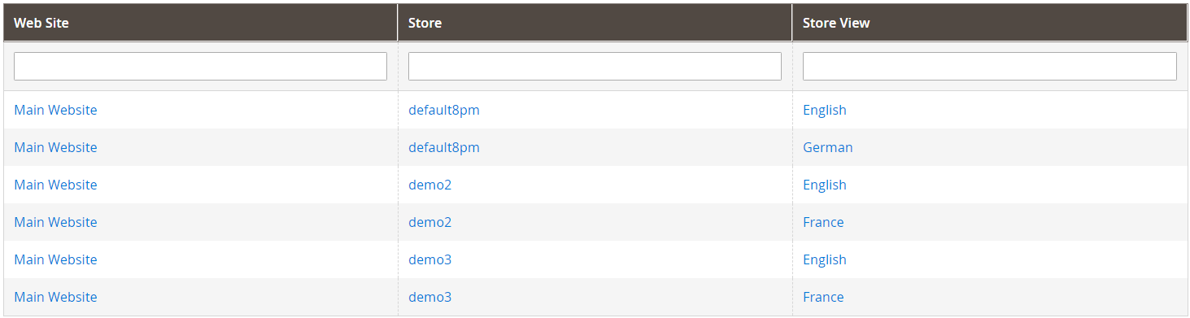

STORE - Configuration - WEB - Default Config
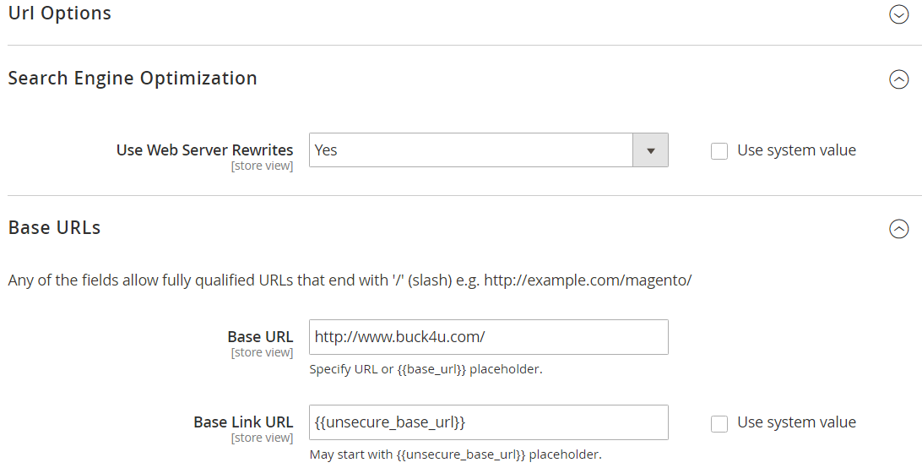

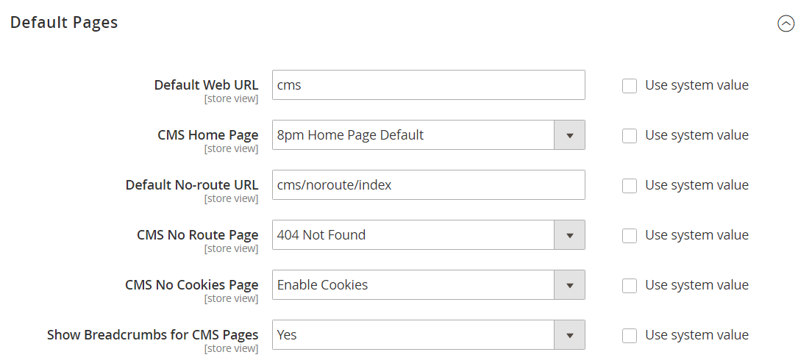

default8pm-english
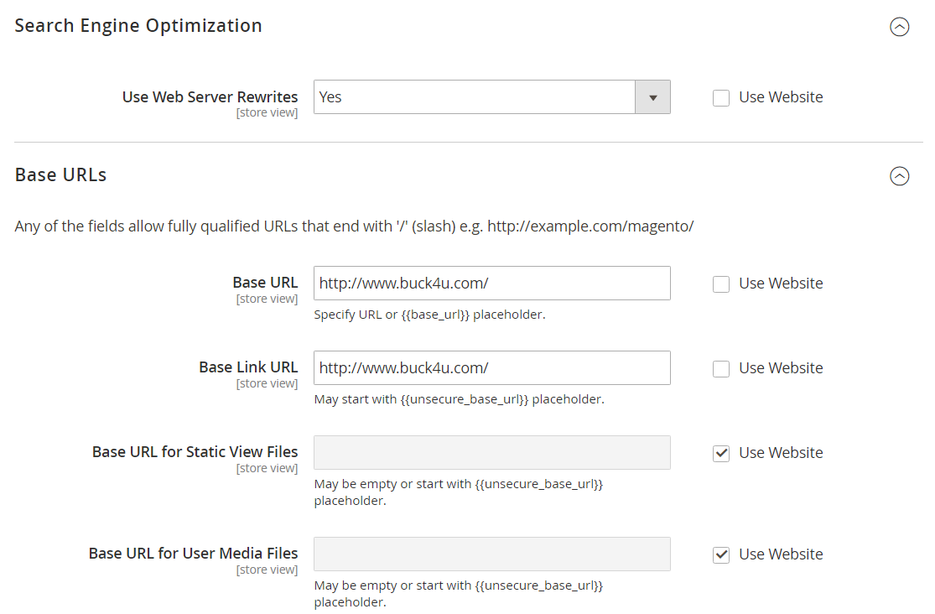

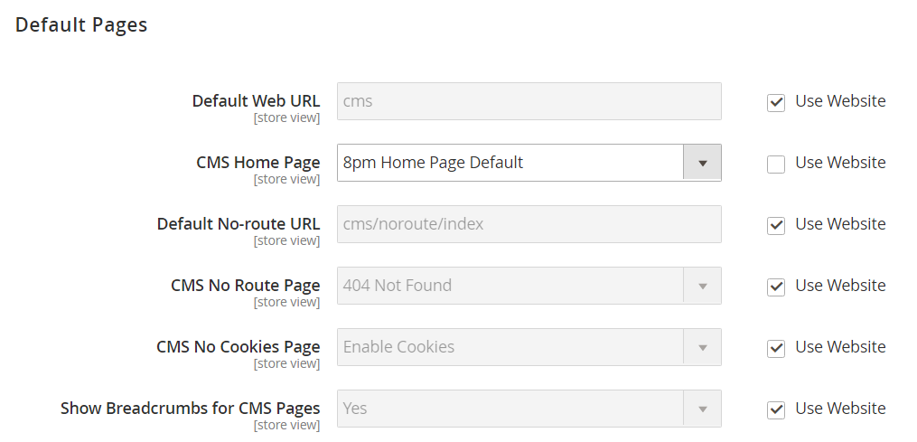

demo2-english
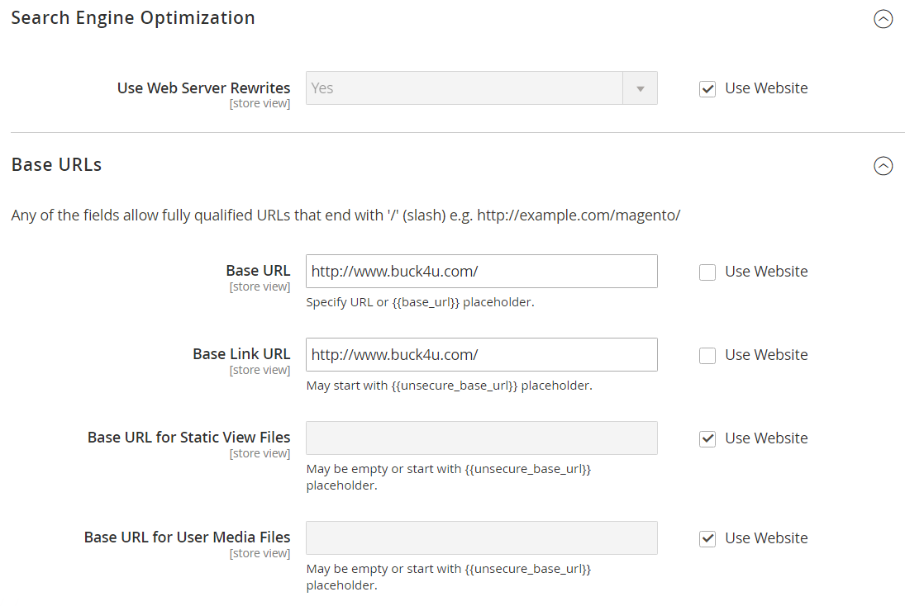

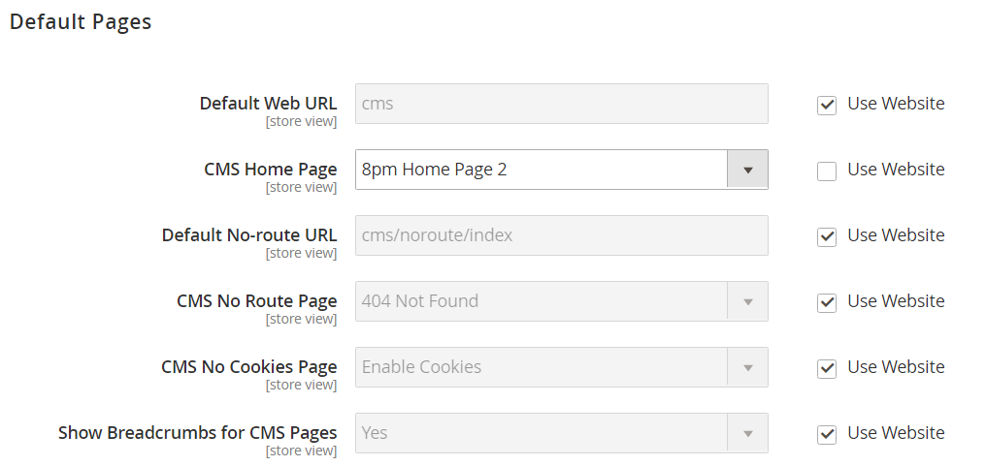

demo3-english
