安裝說明
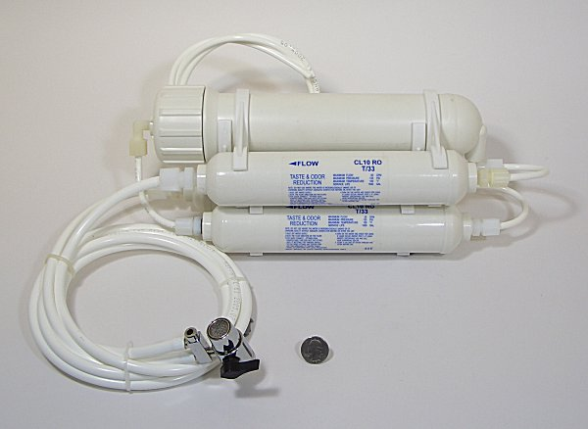
1. 接近自來水水源並可排水的地方。Set up the system in the place near both the water supply and drain
2. 先將原水水龍頭起波器拆下。如下圖 Make the aerator on the faucet disassembled. As photos shown below
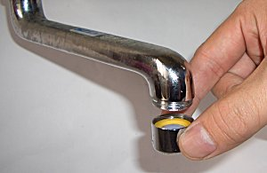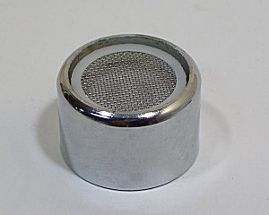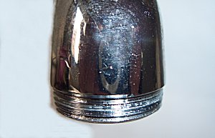
3. 將ro進水接頭(雙切開關)接上。如下圖 Connect the diverter to the faucet.
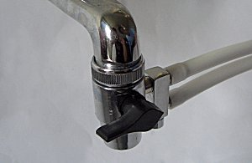
4. 如你的水龍頭為內牙，你必須另購一個轉接頭（雙外牙或其他轉接頭,視水龍頭樣式而定）如下圖. If your faucet is female, you have to buy the style of aerator fit for the diverter. It depend on the style of the faucet. Here are four style of faucet for your reference, as the photo shown below.
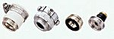
5. 固定1/4水管(廢水),放置於水槽,或插入排水管。make ¼” pipe fixed and then put in sink or insert the drain pipe
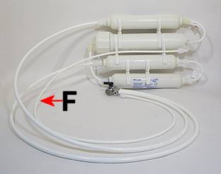
6. 打開原水水龍頭。Open the faucet.
7. 轉動雙切開關。如下圖 Switch the diverter, as shown the photos below
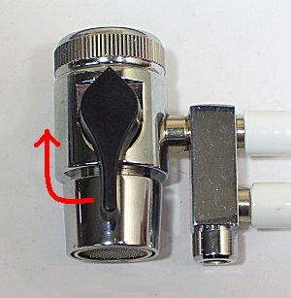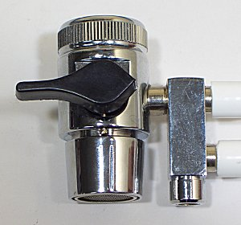
8. 約30秒純水會從純水出口流出 The purified water will flow out in 30 second
注意:前30分鐘過濾出之純水(含活性碳之黑水)不可使用 Attention!! The water has been purified in first 30 minutes contain active carbon. So the water can not be used/drunk
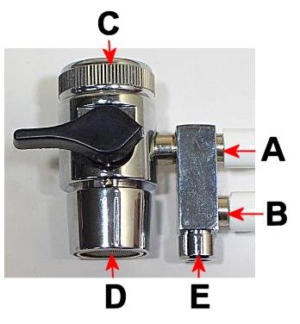
A：自來水 tap water E：純水出口 the exist for purified water
B：純水 purified water F：廢水管 drain pipe
C：水龍頭 faucet
D：自來水出口 the exist for tap water

