Reverse Osmosis systems Installation manual

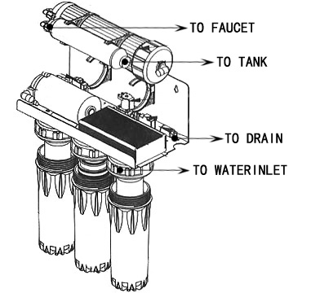
The basic parameters of the product
Rated voltage: 220V
Suitable water pressure: 0.10-0.70MPa
Rated Power: 28.8W
Water temperature: 5-45 ℃
Nissan water: 50 gallons / 24 hours (190L)
Storage tank capacity: 3.2 gallons (12L)
Raw water limits: ≤ 1000PPM (TDS value)
Water hardness: ≤ 180PPM
Flushing means: Automatic
Water quality: municipal tap water
Product Weight: 14 kg
Process:
The first level of meltblown PPF filter: filtering accuracy 5μm-1μm, resistant to weak acid, weak base, and most organic solvents and inorganic solvents. The main removal: suspended solids, sediment, rust, colloid, hair and other impurities. (3-6 months to replace)
The second level of granular activated carbon filter: the absorption rate of 800 Iodine value more than the removal of color, odor, chlorine, pesticides, trihalomethanes organic chemical carcinogens (6-12 months replacement)
The third level. Compressed activated carbon: set adsorption, filtration, intercepted, catalytic role in one of the effective water to remove organic chlorine and other radioactive substances, and decolorization to get rid of odors. (6-12 months replacement)
Fourth level. RO reverse osmosis membrane: 0.0001 micron pore size, completely remove the water, bacteria, viruses, heavy metals, salts, pesticides, trihalomethanes and organic carcinogens (1-2 year replacement)
Activated carbon post in the fifth grade. Small T33: inhibition of bacterial regeneration, regulate water taste, to make the water reach the national direct drinking water standards. (1-2 year replacement)

Accessories Installation diagram
