How to install the RO membrane
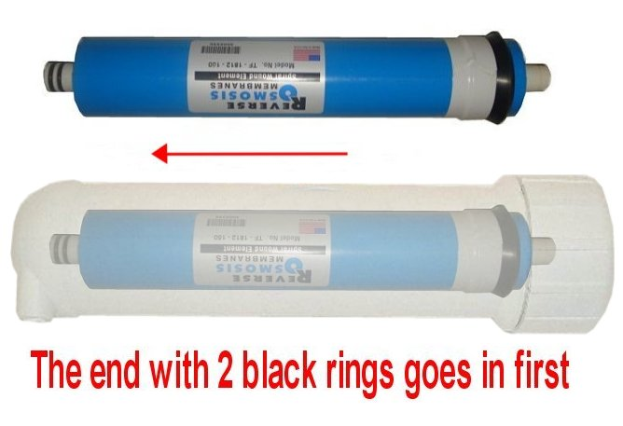

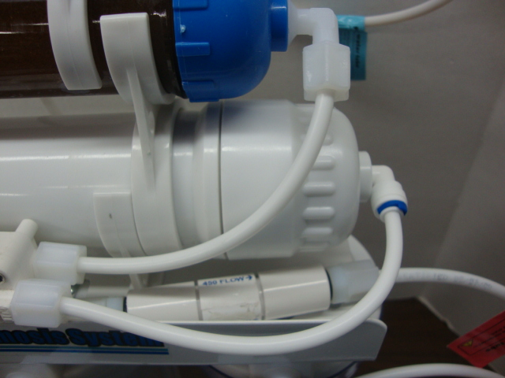
RO units are completely assembled, but the membrane will have to be inserted manually. The fittings may come with a blue snap ring (shaped like a C, used for locking the tube so it doesn't move). C ring is not a necessary part and will not affect the RO system. If your fitting come without C ring, just skip to step 2.

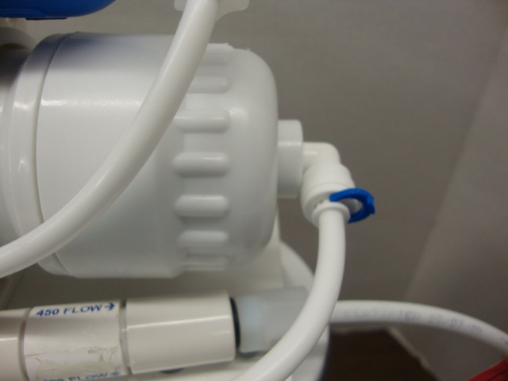
STEP 1

Remove the blue C ring

STEP 2
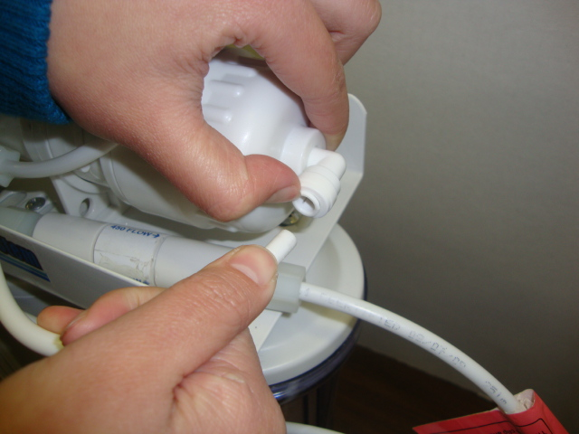
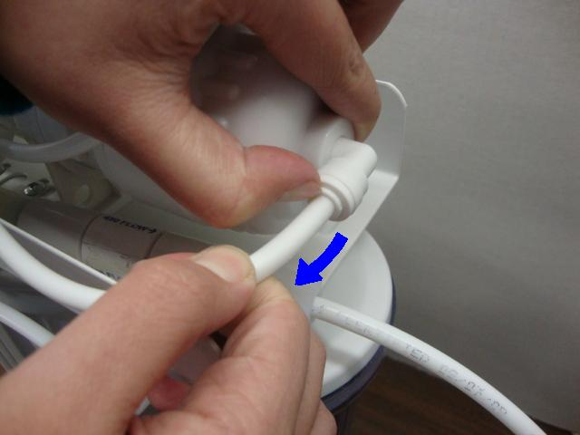

→

Push in the collet/gripper. At the same time, pull out the tube/pipe.
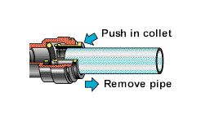
STEP 3

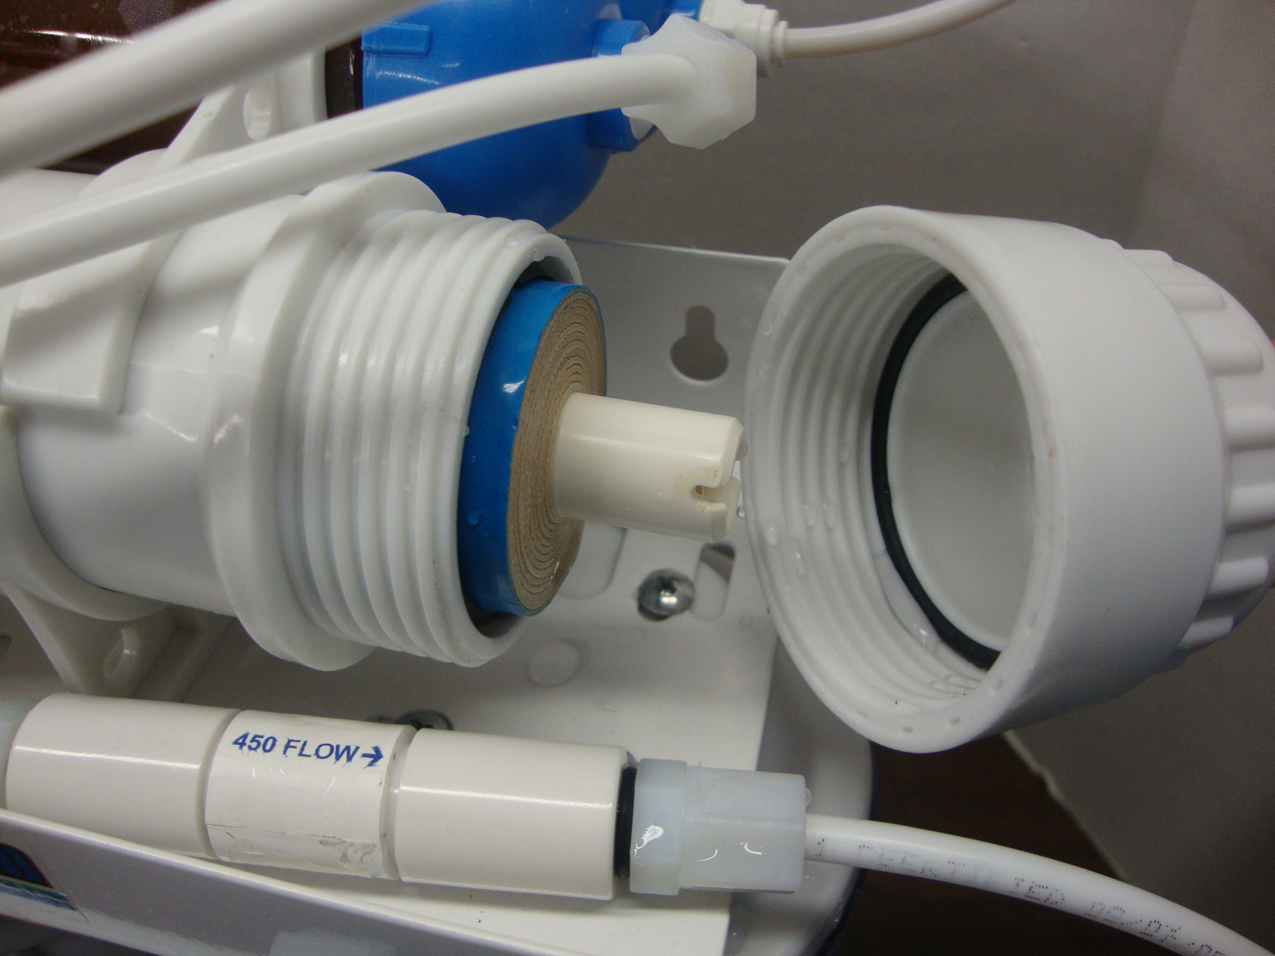
Twist open the cap and insert the RO membrane
Twist the cap back in and tighten it

STEP 4

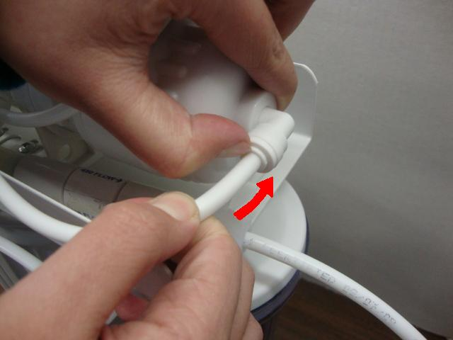
Connect the tube/pipe and push the tube/pipe in the socket all the way
STEP 5

Lock in the blue C ring

