Collet Release Tool (1/4”, 3/8”) Push the tube/pipe in the socket all the way at the same time, Pull out the tube/pipe
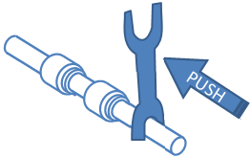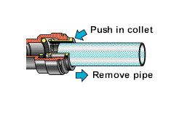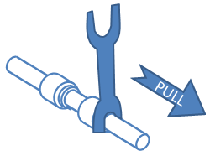

Collet Release Tool (1/4”, 3/8”) Push the tube/pipe in the socket all the way at the same time, Pull out the tube/pipe

Collet Release Tool (1/4”, 3/8”) Push the tube/pipe in the socket all the way at the same time, Pull out the tube/pipe

Collet Release Tool (1/4”, 3/8”) Push the tube/pipe in the socket all the way at the same time, Pull out the tube/pipe
Collet Release Tool (1/4”, 3/8”) Push the tube/pipe in the socket all the way at the same time, Pull out the tube/pipe

