Portable Reverse Osmosis Unit Instructions
0PPM Portable 50/100 GPD Reverse Osmosis RO DI Water Filter

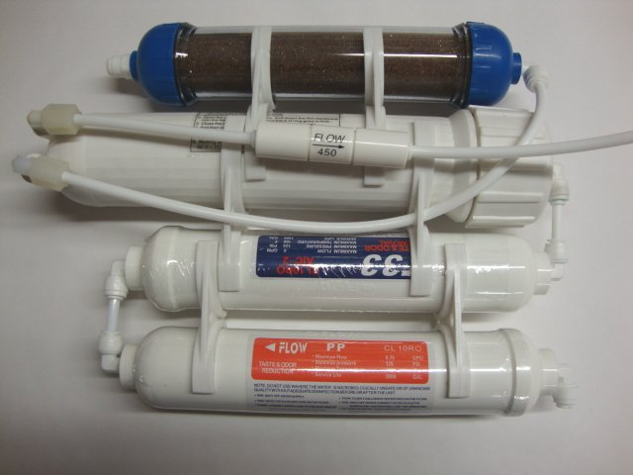

Preparation:

Operation Parameters:
Recommended Total Dissolved Solids (TDS) not to exceed 500
Operating temperature |  | Operating pressure |  | Turbidity | PH
Maxium | 113F | Maxium | 40 PSI(2.95 kg/cm2) | <5 NTU | 4 to 11
Minimum | 33F | Minimum | 80 PSI(5.95 kg/cm2) | <5 NTU | 4 to 11
(at 65 psi, 25C):
Membrane Capacity |  | Time/Pure water | Time/Waste Water
50 Gallons Per Day |  | 1 hour = 2 gallons | 1 hour = 4-6 gallons
100 Gallons Per Day |  | 1 hour = 4 gallons | 1 hour = 8-12 gallons
150 Gallons Per Day |  | 1 hour = 6 gallons | 1 hour = 7-8 gallons
NOTE: Individual performance of each membrane can be higher or lower, depending on the actual pressure

Installation:
The systems can be placed anywhere on the sink counter-top within 5 feet from the faucet. (Or other place near water supply and drain)
1. Insert the RO Membrane. It is shipped sealed for freshness and only can go in one way. (the end with the two small black o-rings goes in first)
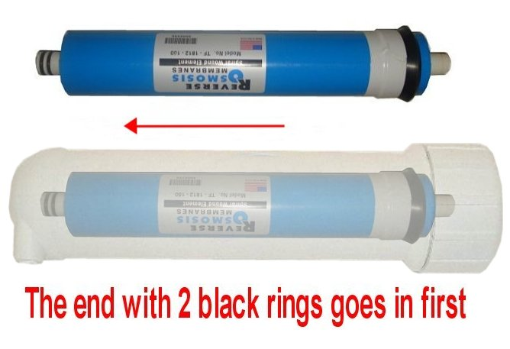
How to install the RO membrane
RO units are completely assembled, but the membrane will have to be inserted manually. The fittings may come with a blue snap ring (shaped like a C, used for locking the tube so it doesn't move). C ring is not a necessary part and will not affect the RO system. If your fitting doesn’t come with C ring, just skip to step 2.
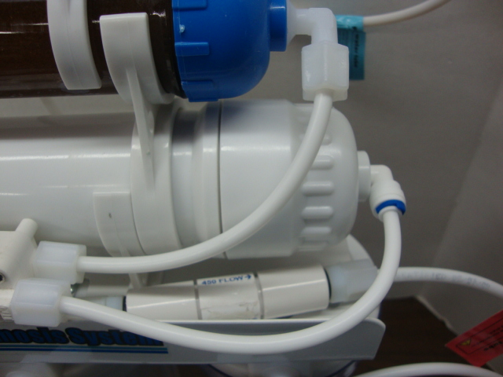
Step 1. Remove the blue C ring
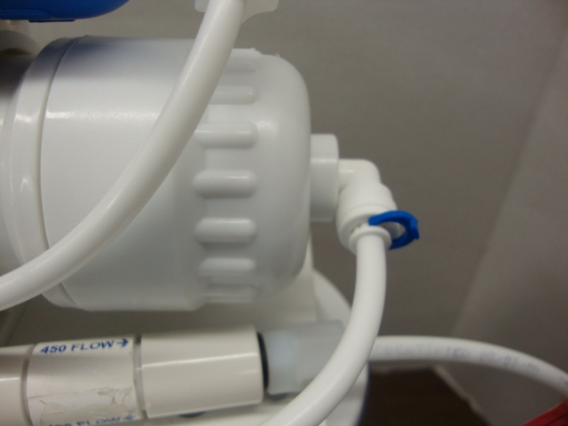

→ → →

Step 2. Push in the collet/gripper. At the same time, pull out the tube/pipe.
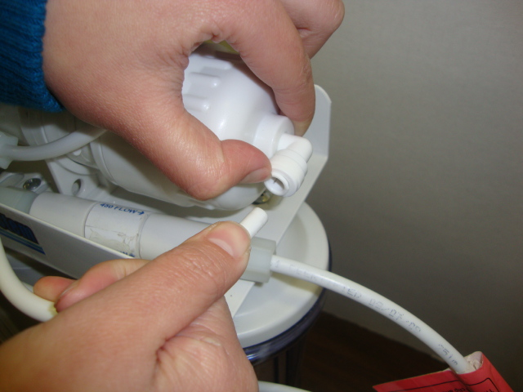
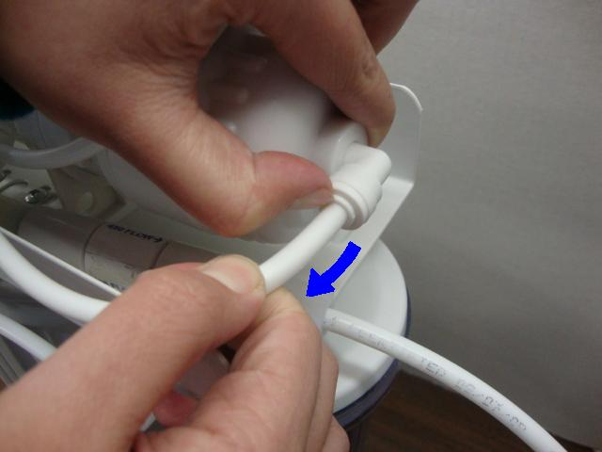

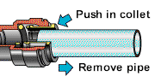

→

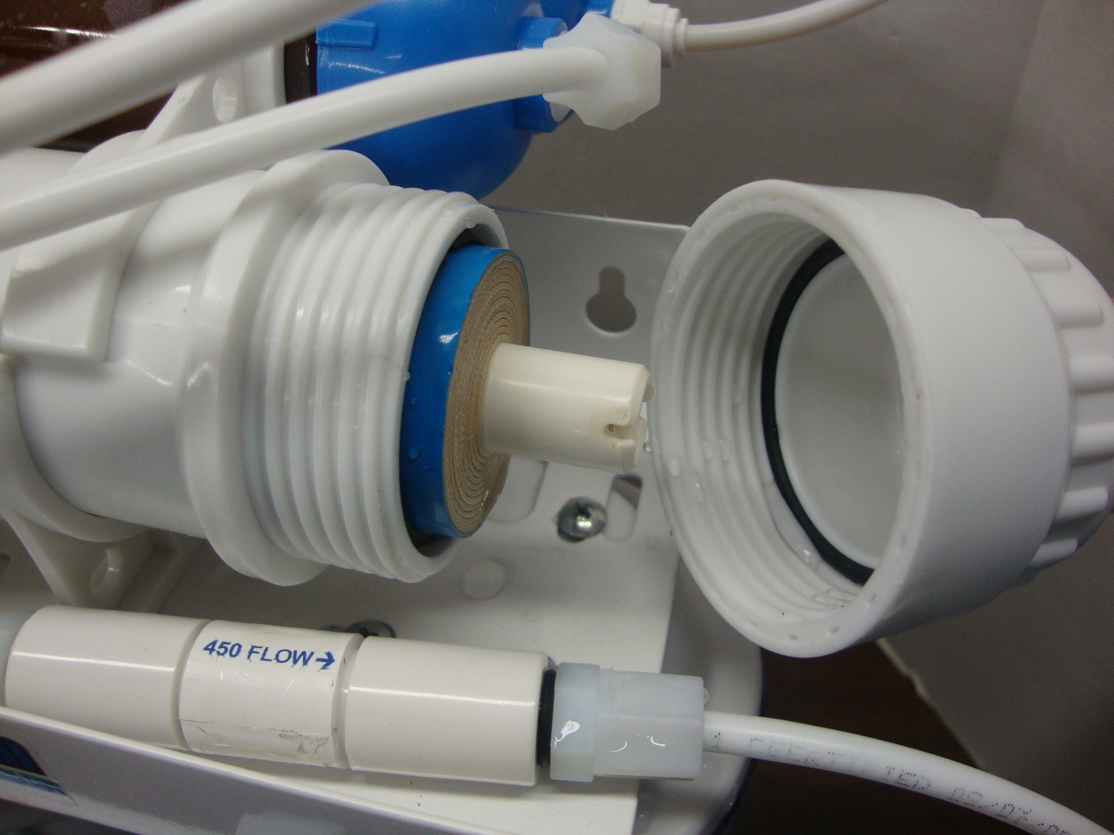
Step 3
Twist open the cap and insert the RO membrane
Twist the cap back in and tighten it

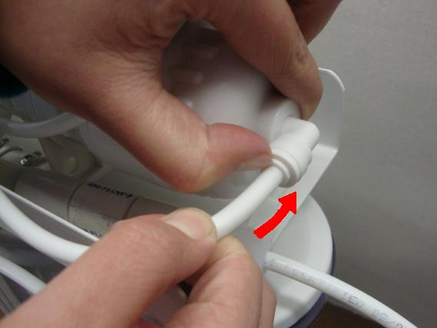
Step 4 Connect the tube/pipe and push the tube/pipe in the socket all the way

2. Connect feed water diverter valve (Two-Way Switch) to the faucet. You may or may not need fitting adapter depending on the type of your faucet and existing attachment. Make 1/4” pipe fixed and then put the 1/4” pipe fixed in sink or insert it the drain pipe.
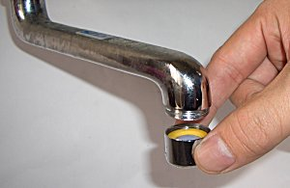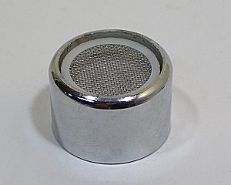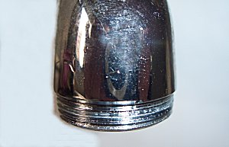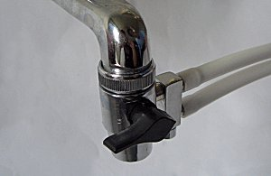

3.Open the faucet and check if there is any leak.
(Cold water only-hot water will cause damage to the system and will void warranty)
4. Turn on the diverter valve and run water through for 30 minutes. (Attention!! The water has been purified in first 30 minutes contain active carbon. So the water can not be used or drunk.)
5. This diverter valve can be left connected to the faucet at all time. When you need to use the tap water, turn the valve to "OFF" position. When you need filtered pure water, turn the valve to "ON" position. Depending on the system, purified pure water will exit a small side port on the diverter valve. Waste Drain water will exit the drain pipe.
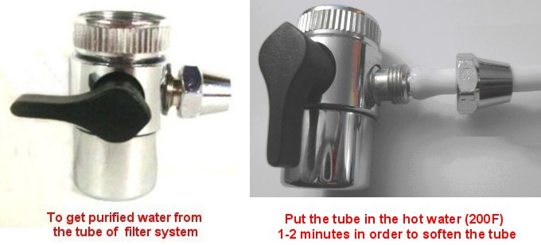
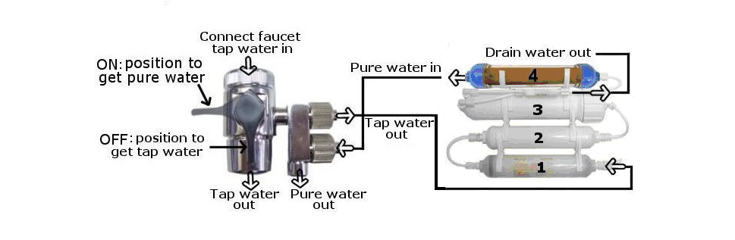
Maintenance:
If the unit is dirty, clean it with soft cloth, warm water and mild soap.
- Do not immerse in hot water.
- Do not use scouring powder.

Changing Filter:
1. Turn the diverter valve to the "OFF" position.
2. Disconnect fittings by unscrewing nuts counter-clockwise or pressing down collets while pulling on tubing. (For quick-connect style fittings)
3. Un-snap old filter from clips and snap new filter in same location. (Note that the direction of flow arrow is pointing the same direction as the previous filter)
4. Membrane changing follows same steps. (Be sure to label tubing and components to prevent incorrect reconnection)
Recommend Schedule:

Filter | Replacement
5 micron PP sediment filter | 6-12 months
Granular activated carbon filter | 6-12 months
0 PPM DI Resin | 500-1000 gallons
TFC RO Membrane | 2 years

Replacement filter model number : FS-3B
Replacement membrane model number : FT-M50, FT-M100
If you have any further question please mail to：ro-sales@purewaterclub.com
