Portable Reverse Osmosis Unit Instructions
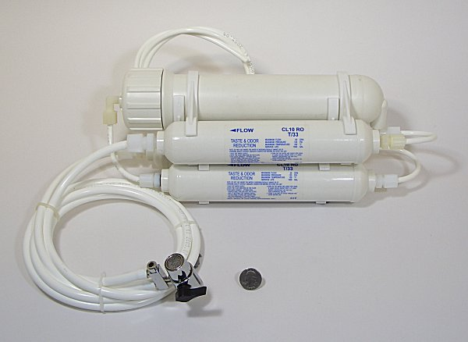
Preparation:
By the instructions, you can solve many problems. Now let’s see what we have in this package：
- Two in-line granular activated carbon filter.
- One in-line 5 micron PP sediment.
- One TFC 100 GPD RO Membrane.
- One Two-Way Switch.
- Three tube：There are two ⅜”, and one ¼” tube.
Before installation, check the contents and make sure everything is actually there. Better to find a mistake now than when you are ½ done.
Installation:
The systems can be placed anywhere on the sink counter-top within 3 feet from the faucet. (Or other place near water supply and drain)
1. Insert the RO Membrane. It is shipped sealed for freshness and only can go in one way. (the end with the two small o-rings)
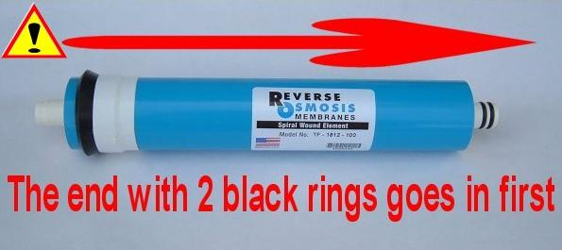
2. Connect feed water diverter valve (Two-Way Switch) to the faucet. You may or may not need fitting adapter depending on the type of your faucet and existing attachment. Make ¼” pipe fixed and then put the ¼” pipe fixed in sink or insert it the drain pipe.
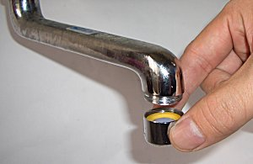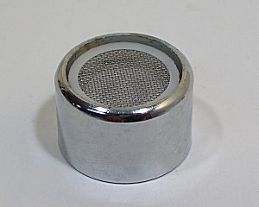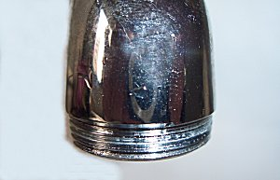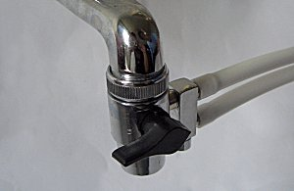
3. Open the faucet (Cold water only-hot water will cause damage to the system and will void warranty) and check if there is any leaks.
4. Turn on the diverter valve and run water through for 30 minutes. (Attention!! The water has been purified in first 30 minutes contain active carbon. So the water can not be used or drunk.)
Off On
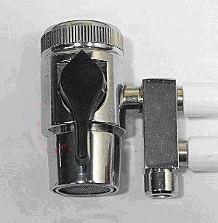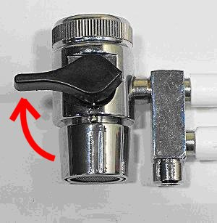
This diverter valve can be left connected to the faucet at all time. When you need to use the tap water, turn the valve to "off" position. When you need filtered water, turn the valve to "on" position.
Depending on the system, purified water will exit a small side port on the diverter valve.
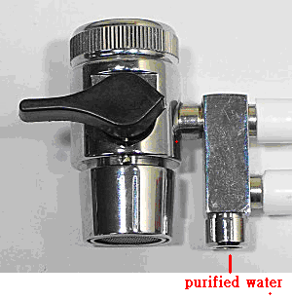
Waste water will exit the drain pipe.
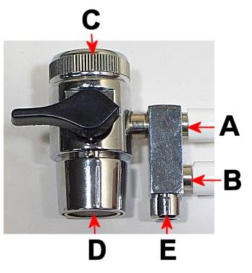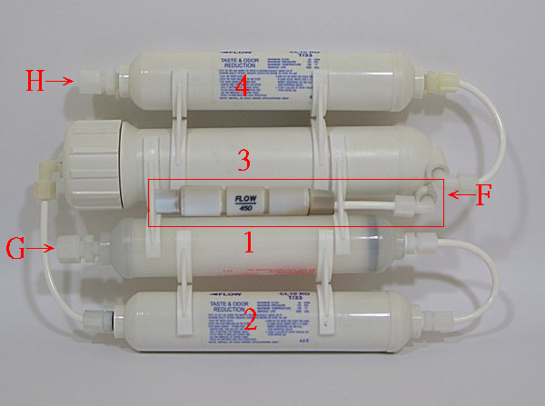
A：connect with the first stage E：the exist for purified water
B：connect with the last stage F：the exit for drain water
C：faucet G：connect with A
D：the exist for tap water H：connect with B

Maintenance:
If the unit is dirty, clean it with soft cloth, warm water and mild soap.
- Do not immerse in hot water.
- Do not use scouring powder.
Changing Filter:
1. Turn the diverter valve to the "off" position.
2. Disconnect fittings by unscrewing nuts counter-clockwise or pressing down collet while pulling on tubing. (For quick-connect style fittings)
3. Un-snap old filter from clips and snap new filter in same location. (Note that the direction of flow arrow is pointing the same direction as the previous filter)
4. Membrane changing follows same steps. (Be sure to label tubing and components to prevent incorrect reconnection)
Recommend Schedule:

Filter | Replacement
5 micron PP sediment filter | 12 months
Granular activated carbon filter | 12 months
TFC 100 GPD RO Membrane | 2years

Replacement Solution：www.purewaterclub.com
If you have any further question please mail to：ro-sales@purewaterclub.com

