Instruction
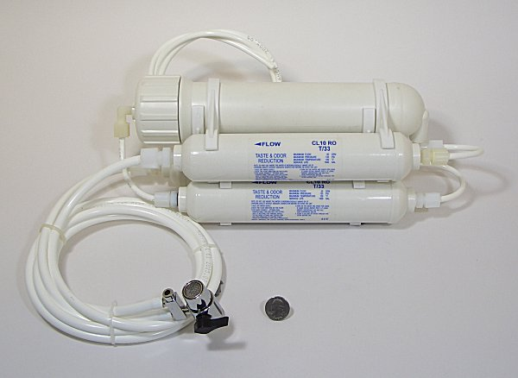
1. Set up the system in the place near both the water supply and drain
2. Make the aerator on the faucet disassembled. As photos shown below
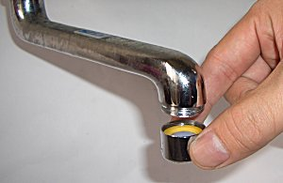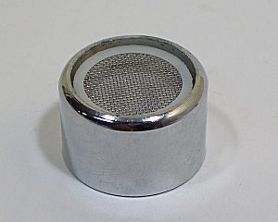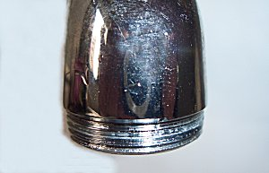
3. Connect the diverter to the faucet.
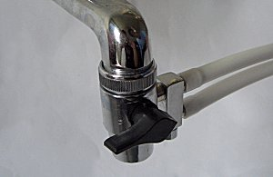
4. If your faucet is female, you have to buy the style of aerator fit for the diverter. It depends on the style of the faucet. Here are four style of aerator for your reference, as the photo shown below.
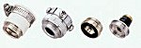
5. Make ¼” pipe fixed and then put the ¼” pipe fixed in sink or insert it the drain pipe
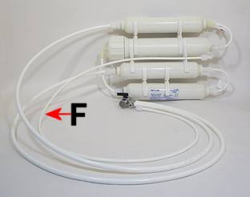
6. Open the faucet.
7. Switch the diverter, as the photos shown below
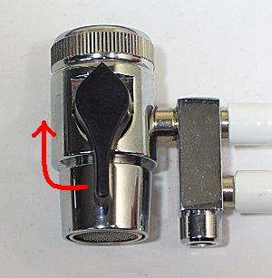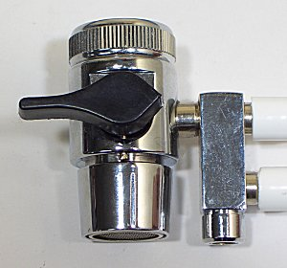
8. The purified water will flow out in 30 seconds
Attention!! The water has been purified in first 30 minutes contain active carbon. So the water can not be used / drunk
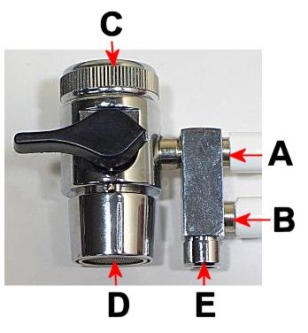
A：tap water E：the exist for purified water
B：purified water F：drain pipe
C：faucet
D：the exist for tap water

