Reverse Osmosis System Instruction manual
1.0 About the Manual
Before reading this manual, there are some things that you need to know. No matter what type you bought, you can solve problems with this manual. If the type you bought without tank, please skip the part 4.0 Prepare the Tank and 6.0 The Faucet. If you bought simple type just with parts 1 to 5.
Parts for all types:
1.) Feed Water Device Needle Valve
2.) Filter Housing Wrench
3.) Saddle Clamp Drain Valve
4.) Reverse Osmosis Membrane
5.) Membrane Housing Wrench
Parts for Normal type only:
6.) Ball Valve for Water Storage Tank
7.) NSF Stainless Steel 4G Pressurized Water Tank
8.) Lead Free Chrome Long Reach Faucet
The most difference between normal and simple type is with pressure water tank or not. The pressure water tank is for your convenience only. It could make the system shut off automatically, as the tank is full. And you also could get the pure water from the tank whenever.
This system could be shut off by connecting any CLOSE container (like pressure water tank, ice maker or floating ball valve...) to collect the pure water. It will stop flow waste water, as the close container is full. If you don't connect any close container to collect the pure water, you have to turn off the incoming tap water manually and the system will NOT shut off automatically.
2.0 Preparation

Tools & Materials Needed for Normal Installation:
• Variable speed (VS) drill
• Carbide grinding burr
• 1/4" (6mm) drill bit
• 7/16” (11mm) drill bit
• 1/2" (13mm) and 5/8” (16mm) open-end wrenches (or adjustable)
• Phillips screwdriver
• Flashlight or droplight
• Teflon tape
• Protective eyewear (i.e.… goggles)
Replacement and Filter Change Interval:
• Sediment Pre-filter: 6 months - 1 year
• Carbon Pre-filters: 6 months - 1 year
• Carbon Post-filter: 6 months - 1 year
• Reverse Osmosis Membrane: 2-3 years
NOTE: Life of filters and membrane depends on the quality of water supplied to the R.O. system

3.0 Check All Parts and Install the RO Membrane
3.1) Examine the contents and make sure everything is actually there. Better to find a mistake now than when you are ½ done.
3.2) The RO membrane contains a preservative solution to prevent microbiological growth and freezing, so please flush this membrane for at least 15-30 minis.
3.3) Open the cap of the RO housing, and insert the RO membrane into this RO housing, the end with two black small O-ring goes in first. It only can go in one way.
3.4) Close the cap of the RO housing as tight as possible. And then connect the tube from the auto-shut-off valve.
3.5) Check if your incoming water pressure is more than 35 PSI, and 60 PSI at best, and the working temperature range: 33F ~ 113F, frozen or warm water will damage the RO membrane.
3.6) There are four ways of ensuring against drips. One is Plumbers Joint Compound (with Teflon), the next is Bath and Tile silicone one of these two should do it...on tough leaks and if you really have to get serious, two-part epoxy will seal anything. Reconnect the hose by pushing in. Teflon tape is the other good thing; however if you insist, pull it tight and work it in to the thread. You may note that some of our threads are sealed with tape...this is special high-density tape made for plastics.
4.0 Prepare the Tank
The tank has an air bladder and a water bladder inside it. It comes pre-set from the factory at 6-8 psi. Do not mess with it. The RO water bladder will push the bladder down until the pressure in the tank is 2/3 of the house pressure. This is when the auto-shut off valve operates and shuts off the incoming water. If you over-inflate this, it will create backpressure on the membrane and mess up the production of RO water (a bad thing). (TRICK: if you want to know the psi in your home, hook the feed water directly up to the tank and fill it. Then, take a tire gauge and measure the pressure in the tank that will be your household psi.)The tank can stand up straight or it can lay horizontal.
a) Put on the tank valve. This is a plastic to metal fitting. It is recommended that some anti-leak materials be used. Choices are the Plumbers Joint Compound or Teflon Tape. I suggest not using cement, as this part may have to be changed out at some point. I like the Joint Compound with Teflon.
The screw on plastic compression nut (white) that holds the hose can be hand tightened. It occasionally drips so I screw this compression nut tightly all the way to the ball valve. Then it never drips.
5.0 Clear the Decks
The next step is to totally clean out under the sink. Get some rags and wipe up any junk that is on the bottom. There will be some water from somewhere during the installation and you want to be able to wipe it up easily and not create mud.
Now, step back and look at where you want the unit and the tank. Remember, you have to service the system so don't make it hard to get at.
I suggest standing it up on the floor inside a drip pan. Either use baking pans or buy one at the store. The disposable aluminum baking pans work fine. We do this because you will get water when you play around with the system or when you change out filters. I reconnected the piping and the system flowed normally (more on how to flush the membrane later). The point is that I got water here and water there, but the drip pan caught most of it. Now that you have made a decision on where everything goes, start the installation.
- The Faucet
This is the hardest part of the installation since it goes all the way at the back and you have to crawl into the cabinet, so let's do it first.
You will be going through one of three types of materials. There is a fourth-porcelain. I strongly advise against you trying it. Either find another spot, or call a Pro.
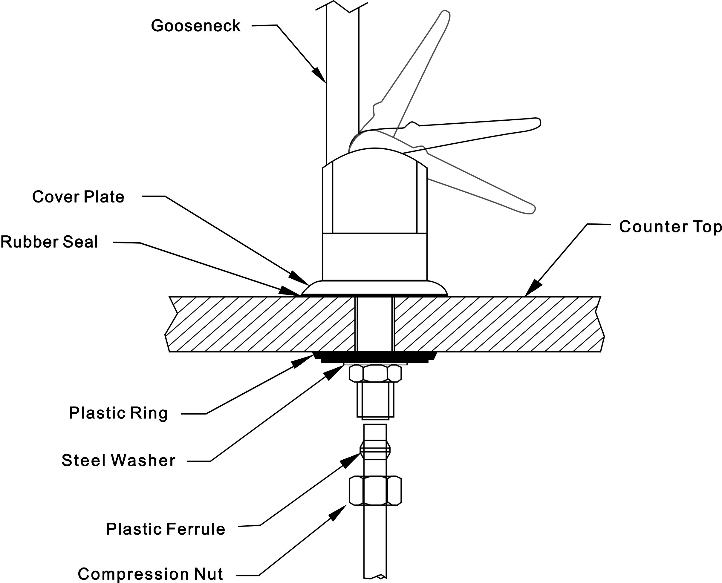

4.1) Laminate: the most common material is a laminated counter top. Find the spot on top, which looks good, and crawl under and see where it is clear. Remember, you have a large plastic washer to put under the counter. The safe thing to do is to drill a pilot hole with your smallest bit first. When comfortable drill a ½ inch hole and assemble the faucet. The rubber gasket goes under the chrome faucet and the plastic washer goes under the counter. After the plastic washer, put in the lock washer and then tighten the nut. You may find the faucet up top turning as you turn the stainless steel nut. Either has someone hold it or get inventive, like put a wrench on it and secure the wrench. Be careful not to damage the faucet surface.

b) Stainless Steel: Do the same as for laminate, except be really sure of your clear space. Take a metal punch (or a big nail) and give the magic spot a good hit. At this indentation drill a pilot hole. A wood drill will not do it. You must use a metal drill bit suitable for stainless. Once the pilot hole is made, follow up with a ½" hole and attach the faucet.
c) Marble or Granite: This is not that hard, but it is boring. You need a diamond tipped drill and about 15-20 minutes. Since you will probably never use it again, you would probably be better off calling in a Pro. Most glass installers have diamond drills and all vendors of stone have them. Some will rent it out. If you insist on doing it yourself, get the Yellow Pages out and find the diamond drill bit. Start the hole by drilling a ½" hole in a piece of scrap wood. This will serve as a guide. Hold the piece of wood and let the diamond drill bit do the work. DO NOT push down or apply pressure. Keep the hole filled with water and wipe out the hole often. It is important to let the weight of the drill be the pressure and to let it just grind away at its own pace (which is slow).
7.0 The Feed Water
DON'T ATTACH TO THE HOT WATER PIPE-IT WILL RUIN EVERYTHING
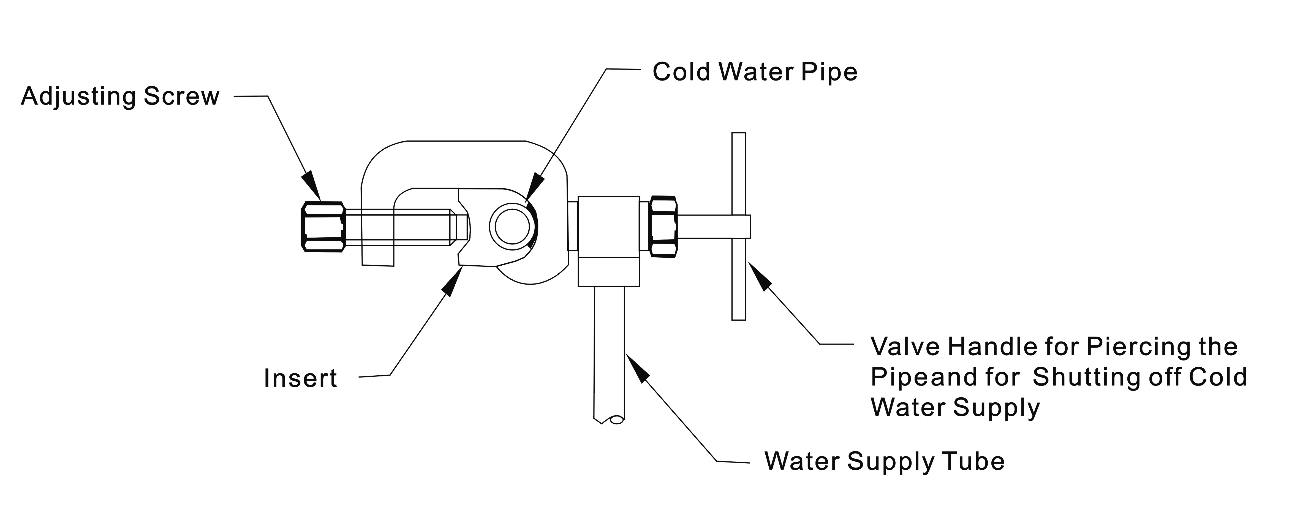

Position the needle-piercing valve where you can get to it. It is normally best to have the valve handle on the right (unless you are left-handed) and the connection facing towards the cabinet doors. Fit the insert to the pipe size-turn the adjusting screw all the way out and place the unit around the pipe and then slide the insert in. Then, tighten the adjusting nut fairly well and double check the insert to make sure it is flush. If everything looks good, then tighten the handle and pierce the pipe. Remember, the insert must be flush with the pipe, or the needle will be off center. Also, make sure you are after the shut off already in the pipe.
7.1) Take the clamp off after piercing and drill out the hole with a 1/8" bit
If you have soft rubber tubing, why not try it? You almost always need to drill out a hole and center the pierce over the hole. The soft rubber tends to expand and fill the needle hole. I have always gotten them to work.

8.0 The Discharge Water Saddle
8.1) Find a place on the discharge pipe under the sink and clamp it on. Try to have it where it will not block anything, like where you want to put the tank. Attach the rubber gasket to the pipe, position the saddle over that spot and screw it on. Drill it out with a 1/4" drill bit. Put the compression nut on the red line (or red label) and push the line into the discharge pipe. It is ok to force it in. Screw the compression nut on fairly firmly. This is usually a no problem area.
Make really sure, that you are above the trap.
If you have a double sink it is OK to place the saddle on the horizontal portion of the piping.

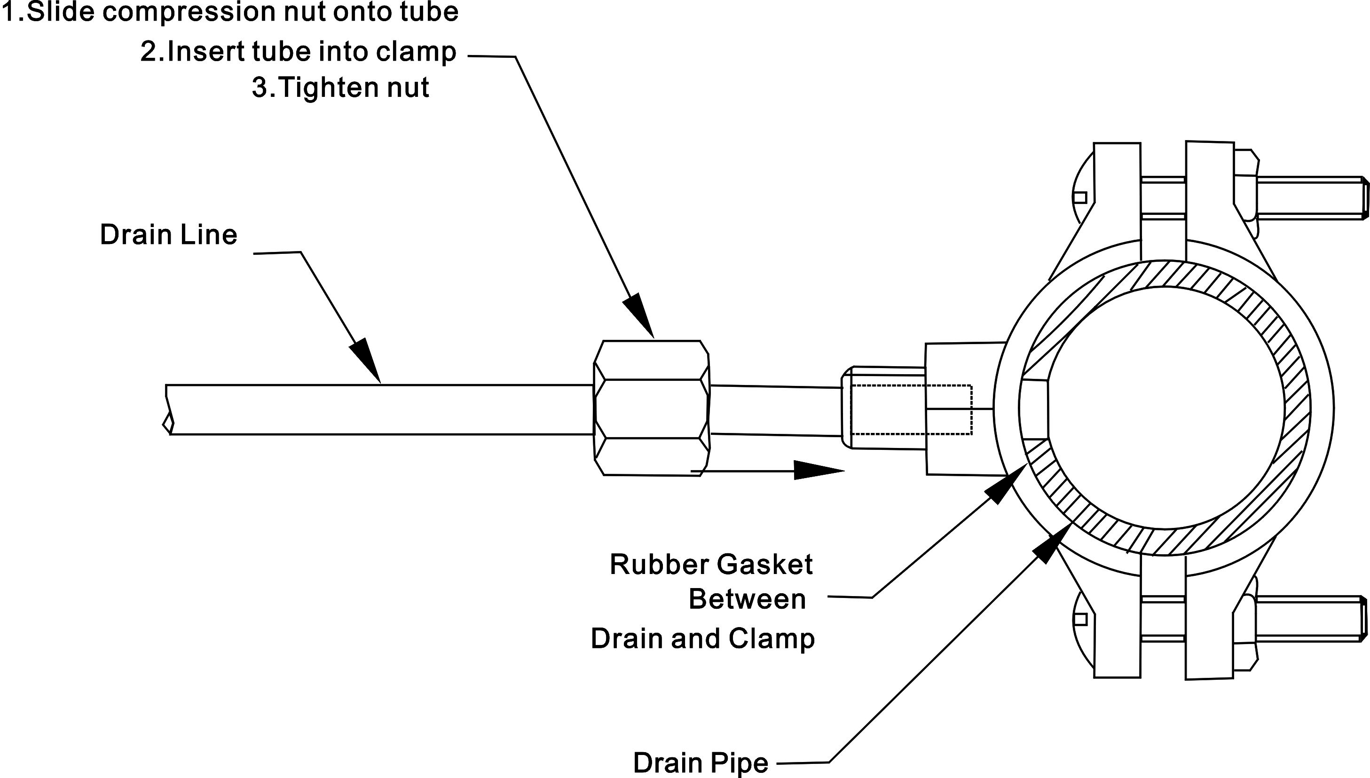

The discharge line has to have backpressure or the RO will not work. Most vendors choose the cheap way to create this backpressure by putting a little plastic insert into the discharge line. It is similar to the little white insert used at the feed water faucet. If your system is slowing down, it may be tired filters or it could be the RO getting silted up. To flush the membrane merely disconnects the line to the flow restrictor so that it points to the red line (or red label) and the water will wash off the membrane. Let it run for 30 minutes.

9.0 Hook up the Tubes and Let it go
9.1) Please connect the yellow tube (or yellow label) “Incoming water tube” to feed water device to get incoming water from tap.
9.2) Please connect the blue tube (or blue label) “Pure water tube” to pressure water tank, floating ball valve, ice maker or any close container to make auto-shut-off valve stop, otherwise, the system will not stop.
9.3) Please connect the red tube (or red label) “Waste water tube” to the drain.
9.4) It is a good idea to flush the pre-filters prior to hooking them up to the IN side of the membrane. Just hook up the red tube (or red label) “Waste water tube” to the third filter ("out"), and let the water run for 10 minutes or so. When it's done, reconnect the red tube (or red label) to the flow restrictor and also hook up the line to the auto shut-off valve.
9.5) That's it. Turn it on, and get the sponge out. After the tank has filled up, dump the whole tank full and refill. The post carbon filter and the tank's water bladder need to be flushed out before drinking the water.
GET A GOOD FLASHLIGHT AND CHECK OVER THE ENTIRE SYSTEM CAREFULLY WHEN COMPLETED. ALSO, REMEMBER THAT WHEN THE TANK FILLS UP COMPLETELY, THE SYSTEM IS THEN FULLY UNDER PRESSURE AND THAT IS WHEN THE TINY LEAKS OCCUR. IF THEY ARE GOING TO OCCUR, SO KEEP YOUR EYE ON IT FOR A COUPLE OF DAYS.
ALSO REMEMBER THIS IS PROBABLY THE ONE AND ONLY TIME YOU WILL DO THIS. EXPECT A COUPLE OF BUGS. THEY WILL BE WORKED OUT.

Hints
1.) Icemakers: it is a good idea to hook up your icemaker if it is accessible. Remember, the point of having an RO is for good health and for good taste, Ice-cubes melt. Why buy 12 year old scotch and put it with "chlorine-cubes"? That's very unhealthy. Freezing does not kill more bugs. Put a T connector after the final filter and before the faucet and run a line to the refrigerator.
2.) Pets: are you spending a small fortune on vet's bills and quality animal food and giving them water with poisons and chemicals in it? (Chlorine is a poison).
3.) Plants: they are living things also. No serious hydro farmer uses tap water. Don't poison your plants. They will like you for it.
LAST TIP: THE SYSTEM YOU BOUGHT WILL WEAR OUT. THE THINGS THAT WEAR OUT ARE THE RO MEMBRANE, THE AUTO-SHUT OFF VALVE AND THE TANK. OTHER PARTS, LIKE THE FLOW RESTRICTOR AND THE RED LINE (or RED LABEL) GET CAKED WITH THE JUNK THAT IS BEING SENT DOWN THE DRAIN. THE RUBBER "O" RINGS WILL GET OLD AND CRACK, JUST LIKE GASKETS ON YOUR CAR. IF YOU START REPLACING THEM ONE BY ONE, YOU ARE GOING TO GO CRAZY AND WILL SPEND LOTS OF TIME AND MONEY. THE RO MEMBRANE IS SWOLLEN IN THE HOUSING AND DIFFICULT TO REMOVE. THE BOTTOM LINE IS THAT IT IS CHEAPER AND EASIER JUST TO JUNK THE SYSTEM (OR KEEP IT FOR PARTS) AND BUY A NEW ONE EVERY 5 YEARS, OR WHEN THE RO MEMBRANE DIES. YOU WILL KNOW WHEN THE RO MEMBRANE DIES...THE WATER WILL START TASTING BAD. IF YOU ARE MORE PARTICULAR, GET A TDS METER AND CHECK THE TDS OF THE FEED WATER AND THE TDS OF THE RO WATER. WHEN THERE IS NO DIFFERENCE, THE RO IS DEAD. THERE WILL BE A GRADUAL DECAY.
REMEMBER-CHANGE FILTERS EVERY 6 MONTHS. THIS IS FOR AVERAGE USE THAT IS 150 GALLONS PER MONTH OR 5 GALLONS PER DAY. IF YOU HAVE HEAVY DUTY USE, ADJUST ACCORDINGLY...I.E. 300 GALLONS PER MONTH WOULD REQUIRE FILTERS CHANGES EVERY THREE MONTHS.

Trouble Shooting
All problems are fixable and they all will show up in the first 24-48 hours after the system is fully charged.
1.) "The system is not making water"
This is almost always a psi problem. First question..."Are you on well water?” If so, then kick the regulator up. Check the psi of the house by the tank method (above). 40 PSI is about as low as you can go. If the psi is low it often is a bad hole on the feed water pipe. Drill it out. If you have good psi to the IN side of the pre-filters, then check the following:
a) Check to see if the water is flowing out the discharge line...if so, then the membrane is getting water.
b) Disconnect the white line from the in side of the auto-shut off valve... (That thing with four connectors) if water is coming out, the RO is producing and the problem is between there and the faucet. Maybe a defective auto-shut-off valve.
c) If the red line (or red label) is flowing and the line from 4th stage is not, maybe blocked check valve at RO Housing. There are two outlets on the out end of the RO Membrane. One goes to the discharge saddle and the other is purified water.
d) If unit has been in service for a while, the problem is probably clogged filters. Pull the filters. Test them one at a time by putting them into the first filter position and see if it flows. Clogged filters are usually only associated with well water or with really turbid water.
e) The RO Membrane has silted up. Very rare unless very bad feed water. The RO Membrane is self-flushing. Try flushing the membrane by disconnecting the line to the restrictor. This will allow all of the flow to wash the membrane off.
2.) "My filters are leaking"
Loose O-Ring. Take housing off and make sure they are properly aligned. Housing not tight enough...tighten. Do not use plumbers gunk here...they housings are supposed to seal.
3.) "I have leakage from a screw-in connector"
a) Not tight enough…Gently apply pressure...too much and you will strip the threads
b) If that does not work, remove and apply Plumber's Joint Compound or dry off and use silicone or just glue it.
4.) " I have some leakage coming from the tank"
If from the top...tighten screw at the top. If from middle...tighten the compression nut all the ways) it from the bottom...tightens gently, if that does not work remove and apply Joint Compound or Teflon tape.
5.) Trick on how to check PSI:
The RO system does not use electricity and works on water pressure. Therefore, adequate PSI is critical to the proper functioning of the system. There are three critical points at which the PSI should be checked. A PSI in-line pressure gauge is available, but you can also use the water tank with a tire gauge to accomplish the same thing for free. Here is how you do it:
a) The PSI from the "feed water" yellow tube (or yellow label)....take this line and run it directly to the tank and let it fill...take the tire gauge and read the PSI...it should be over 40 PSI....if not, then well water customers should kick the regulator up to 50~70 and city customers should drill out the needle valve hole with a 1/8" bit. The 40+ PSI is for normal water...if you have 800 TDS then figure 50 PSI...1200 TDS figure 60 PSI 2000 TDS figure 70 and sea water 36,000 TDS figure 700 PSI ...(don't try it as the unit will blow up). IF YOU HAVE NASTY TDS AND MARGINAL PSI, THEN YOU WILL NEED A BOOSTER PUMP.
b) The PSI from the white tube after the three pre-filters...this should also be 40+ PSI...if it is lower that 35 PSI (the absolute min.) and the yellow line (or yellow label) is ok, and then change out the filters. When the reservoir is low, we pump muddy water...I had to change my filters after less then a month.
- ) The water coming from the final filters with has some carbon dust in it for a while. This will, because elevated readings. Accurately measure the performance of the DI or the RO Membrane, take the reading from the blue line (or blue label) after the RO or the DI. 0902.0501.2000

Reverse Osmosis System Layout

