Portable Reverse Osmosis Unit Instructions

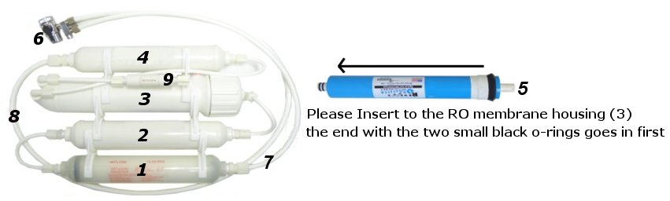

Preparation:
By the instructions, you can solve many problems. Now let’s see what we have in this package：
- In-line 5 micron PP sediment.
- In-line granular activated carbon post-filter.
- RO Membrane Housing.
- In-line granular activated carbon post-filter
- TFC RO Membrane
- Two-Way Switch Faucet Adaptor valve.
- 5 feet 1/4” tube for Tap Water Incoming
- 5 feet 1/4” tube for Pure Water Outgoing
- Flow Restrictor with 5 feet 1/4” tube for Drain Water Outgoing
Before installation, please check the contents and make sure everything is actually there. Better to find a mistake now than when you are 1/2 done.
Installation:
The systems can be placed anywhere on the sink counter-top within 5 feet from the faucet. (Or other place near water supply and drain)
1. Insert the RO Membrane. It is shipped sealed for freshness and only can go in one way. (the end with the two small black o-rings goes in first)
2. Connect feed water diverter valve (Two-Way Switch) to the faucet. You may or may not need fitting adapter depending on the type of your faucet and existing attachment. Make 1/4” pipe fixed and then put the 1/4” pipe fixed in sink or insert it the drain pipe.
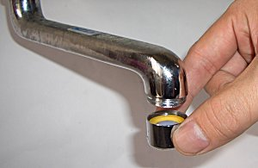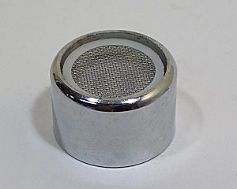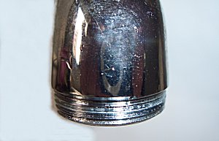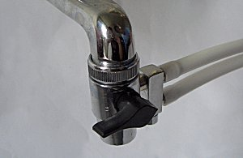

3. Open the faucet (Cold water only-hot water will cause damage to the system and will void warranty) and check if there is any leak.
4. Turn on the diverter valve and run water through for 30 minutes. (Attention!! The water has been purified in first 30 minutes contain active carbon. So the water can not be used or drunk.)
5. This diverter valve can be left connected to the faucet at all time. When you need to use the tap water, turn the valve to "OFF" position. When you need filtered pure water, turn the valve to "ON" position. Depending on the system, purified pure water will exit a small side port on the diverter valve. Waste Drain water will exit the drain pipe.

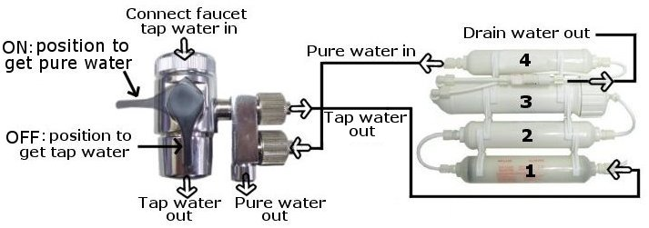

Maintenance:
If the unit is dirty, clean it with soft cloth, warm water and mild soap.
- Do not immerse in hot water.
- Do not use scouring powder.
Changing Filter:
1. Turn the diverter valve to the "OFF" position.
2. Disconnect fittings by unscrewing nuts counter-clockwise or pressing down collets while pulling on tubing. (For quick-connect style fittings)
3. Un-snap old filter from clips and snap new filter in same location. (Note that the direction of flow arrow is pointing the same direction as the previous filter)
4. Membrane changing follows same steps. (Be sure to label tubing and components to prevent incorrect reconnection)(100125.v2.300)
Recommend Schedule:

Filter | Replacement
5 micron PP sediment filter | 12 months
Granular activated carbon filter | 12 months
TFC RO Membrane | 2 years

Replacement Solution and Other Products：www.purewaterclub.com

If you have any further question please mail to：ro-sales@purewaterclub.com

