#$K+Overview
The DSR Series of Digital Surveillance Recorder has inherently been designed with flexibility of different video camera inputs and display different camera images in real time. Notwithstanding the different inputs and display, all models will have the same features which are kept as uniform throughout the series.
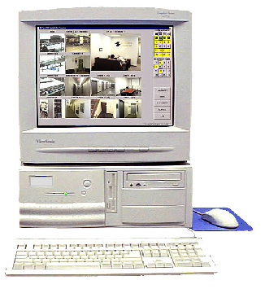

#KStandard Features

General
- DSR provides multi-channel video recorder, multiplexer and video transmission server functions
- Support both PAL and NTSC standards
- Support full resolution video (768x576 PAL, 640x480 NTSC)
- Provide real-time digital video compression
- Provide configuration retaining
- Provide status retaining for auto start
- Easy to use graphic user interface
- Easy to expand by software upgrade and system integration
- Multilingual Capability

Camera Viewing & Recording
- Support up to 16 camera inputs with multi display modes
- State of the art real-time display and recording under optimum condition of up to 4 channels
- Programmable timer for recording
- Provide circular recording mode to allow recycling use of the recording drives
- Provide archive-recording mode to allow directly recording to a specific removable drive
- Audio recording with a selected camera
- Pan/Tilt/Zoom Control (selected Protocol)

Video Playback & Search
- Simultaneous playback and recording
- Playback with sophisticated search functions (by camera, events, time/date)
- Snap shoot with print and save

Alarm & Motion Detection
- Alarm I/O interface for alarm triggered recording
- Motion detection recording
- Pre-alarm recording
- Scheduled alarm and motion detection function

Remote Playback & Online View
- Intelligent remote player through telephone dial up, LAN and Internet connectivity
- Video transmission server function provide online viewing of live video with password logon control and event log
- Recording in remote client machine
- Playback recorded videos (both local recorded and server recorded files)
- Alarm alert function

#KOptional Features
- Video displays on SVGA monitor and support a secondary display unit
- Fast Video Compression/decompression (optionally selected Codec)

$+Starting the DSR
#KTurn On The Power
Make sure that the line voltage selector in the rear panel is selected correctly.
Press the “POWER” switch in the front panel of the DSR to power up the unit.

#KLogon
- After the system start-up process, the DSR main screen will appear.
- Click the Log ON/OFF button, a Logon Screen dialog box will pop up for input.
- Two default usernames are available: “SUPER” and “OPERATOR”.
- The factory default password is “”, i.e. NULL for either case.
- When you logon as “SUPER”, you can click on the Utility button to change the logon password (to be discussed in more detail on System Operation Data section).
- However, if you logon as “OPERATOR”, the Utility button will be disabled to prevent the password and some other system and recording settings from being modified by the operator.

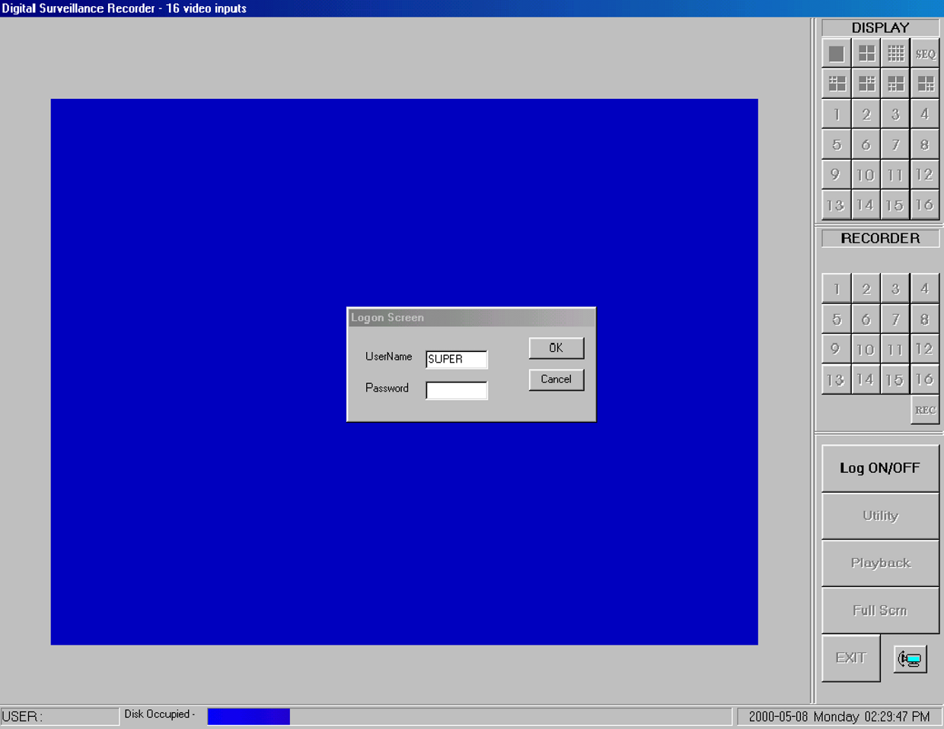

#KThe Main Screen
- Two control panels and various common control buttons are displayed on the right hand side of the main screen.
- The username is shown on the lower left-hand corner.
- A progress bar located at the bottom of the screen shows the amount of storage occupied and available for video recording. The color of the status bar will gradually change from BLUE – when it is empty to RED – when it is full.
- The current time/date is shown on the lower right hand corner.

$+Camera Viewing (Multiplexer Function)
#KDisplay Control Panel
A “DISPLAY” control panel is implemented on the upper right hand corner of the main screen so that the user can interact with the unit more easily.

The “DISPLAY” panel consists of “display mode” buttons, “camera” buttons and a “sequence” button respectively (see following Figure for Models 104, 208 and 416).
All of the push buttons have their individual built-in indicator lights. Once the button is pressed, it toggles on and off with the indicator light on and off to indicate its status correspondingly.

Tip:
You are able to know which camera(s) is/are being displayed by the “DISPLAY” panel indicator lights, and you can press the buttons on the “DISPLAY” panel to enter your display input right away.

For Models 104, 416

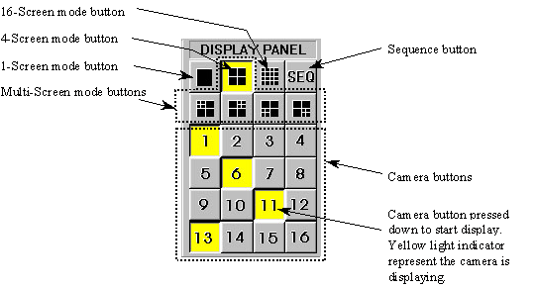

For Model 208

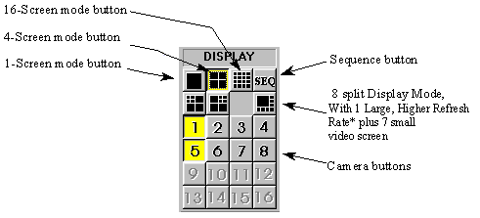

Tip:
No camera button can be selected prior to the mode selection. User should click on one of the display mode button first.

#K1-Screen Mode
- Click the 1-Screen mode button on the display control panel to select this mode.
- Only one camera can be selected for display.
- Click the camera button to select camera to display in this mode.
- The down button will light up in yellow.

#K4-Screen Mode
- Click the 4-Screen mode button on the display control panel to select this mode.
- Four cameras can be selected for display simultaneously.
- Click the camera buttons to select camera(s) to display in this mode.
- The down buttons will light up in yellow to indicate the display status.

The camera display in 4-Screen mode is assigned as the following figure for easy operation.

For Model 104

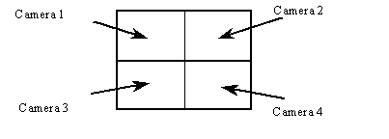

For Models 208 & 416

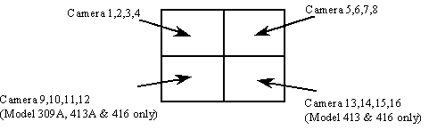

Tip:
To make the most use of the 4-Screen real time display of the unit, consider the arrangement of your camera connections to the unit. You can think of the cameras that you want to display simultaneously in a 4-Screen mode as a group. Connect the grouped cameras to the inputs of the unit in a horizontal arrangement instead of in a vertical arrangement.

Example: Two possible horizontal arrangements of the grouped cameras are shown in the following Figure.

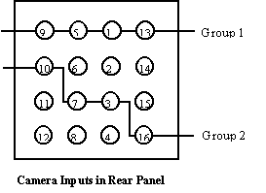

(Shown as the standard version of DSR system product, for packaged products, the actual location of camera assigned will vary with the motherboard and slots being used)

#KMulti-Screen Mode
- A group of four multi-screen buttons is implemented for multi-screen display control.
- The multi-screen buttons are enabled only under the 4-screen mode.
- You can click on any of these mode buttons to further split any quadrant of the original 4-Screen display into a smaller quad display (quad within a quad).
- All multi-screen mode buttons can be selected simultaneously.

Example:
Using the following multi-screen buttons configuration as an example, the camera display will be assigned as shown in the Figure on the right hand side.

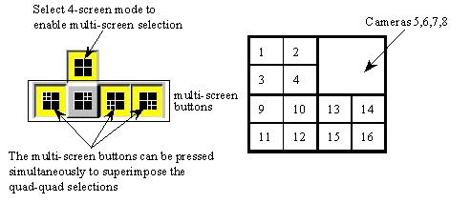

#K8-Screen Mode
(This mode is available for Model 208 only)

- Click the 8-Screen mode button on the display control panel to select this mode.
- All cameras will be displayed simultaneously at first time entry to this mode.
- Click the camera buttons to select or de-select camera(s) to display in this mode.
- The down buttons will light up in yellow to indicate the display status
- Click on the surrounding (small) screen will cause the camera on display to be swapped with the one at the center (Large) screen.
- Keep doing the swapping until the designed cameras are assigned to the respective screen.
- The assignment will be maintained even if there is a momentary change to other multi-screen modes, but it will return to its default by logging out and on again.

The camera display in 8-Screen mode is assigned as in the following Figure by default.

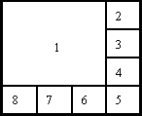

#K16-Screen Mode
- Click on the 16-Screen mode button on the display control panel to select this mode.
- All cameras will be displayed simultaneously.
- The camera buttons will then all light up in yellow to indicate the selection of all the cameras.

The camera display in 16-Screen mode is assigned as in the following Figure.

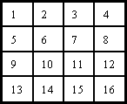

#KRapid Zoom
You can jump to one-screen display mode instantly.
Simply double-click on the desired image on screen, and the image of that screen will be zoomed to “one screen” mode immediately.

For an example, you can zoom camera 3 from 4-Screen display mode to 1-Screen display mode by double clicking the camera 3 image on the screen.
You can return to the original display mode by clicking on the previous display mode button.

#KFull Screen Display
- Click on the “Full Scrn” button on the lower right hand side of the main screen to display the video(s) in full screen.
- All the control panels and buttons will be hidden and only videos will be displayed on the screen in order to fully utilize the displaying area of the monitor.
- Right-mouse click on any part of the full screen to restore the normal control panel display.

#KSequence
- Click the “SEQ” button on the display control panel to toggle the sequence function on or off.
- The indicator of the button lights up in yellow to indicate the sequence function.
- The function of sequencing is effective for all display modes, except for the 16-Screen mode.
- The user can select individual camera(s) for sequencing display.
- For the sequence parameter setup and the implementation example, please see the Display Sequencing under Option Setting section of this manual.

Note:
When the unit is in sequence mode, all the camera selection buttons inside display panel will be inhibited. You can click the “SEQ” button to toggle it off to re-gain manual access of the camera selection.

$+Remote Online Viewing and Playback Recorded Video
#KIntelligent Remote Player
- An Intelligent Remote Player is designed to provide online viewing and playback recorded video functions in the remote client station.
- Please refer to the Intelligent Remote Player User Manual for detailed operation procedure.
- Please refer to Section 3 of the DSR Installation Guide for the system setup for Remote Player operation.

#KDSR Folder Sharing for Remote Playback
(Upgraded feature)
- In order to allow remote playback to work, DSR should have to share the video folder(s) so that the remote playback station can find the DSR machine inside its Network Neighborhood and read the shared video folder(s) in the DSR unit.
- The expected Share Name of the video folder(s) is listed as follow:

Folder Name | Share Name
c:\DSR-video | dsr-video
d:\DSR-video | dsr-videod
e:\DSR-video | dsr-videoe
… | …
i:\DSR-video | dsr-videoi
… | …

- Go to each video folder in every available hard drive, point and right click the mouse on the "DSR-video" folder icon. Select Properties-> Sharing-> Shared As and then input the corresponding Share Name.
- Add the "File and printer sharing for Microsoft Networks" service to the Network setting of the DSR unit. Click Start->Settings->Control panel->Network->Add->Service->Add-> File and printer sharing for Microsoft Networks->OK

Note:
To make sure (diagnose) the system and network are correctly set up for the remote playback function: - the remote playback station should be able to find the DSR machine inside its Network Neighborhood and can read the DSR machine shared video folder(s).

#KDSR Network Configuration for Remote Online View
DSR provides Video Transmission Server Function in order to support remote online view through TCP/IP networking.
The following table describes about the network configuration for different types of connection.

Through Dial-Up connection | In DSR unit:  - A Dial-up Server should be installed in the DSR unit to allow the DSR unit to receive telephone call.  - The Dial-up Adapter of the DSR unit should have TCP/IP and NetBEUI protocols attached and with a fixed IP address assigned by the administrator.  - Please refer to the Appendix of How to Setup a Dial-up Connection in order to set up the DSR unit as a Dial-up server machine.  In Remote Client side:  - Remote unit should make a New Connection for the DSR unit inside the Dial-Up Networking folder.  - Please refer to the Appendix of How to Setup a Dial-up Connection in order to set up the remote unit as a Dial-up client machine.  - Remote user input the IP address of the DSR unit to start on-line view.
Through LAN connection | In DSR unit:  - The DSR unit should have a Computer name and Workgroup assigned correctly, so that other machines within the LAN can see it in their Network Neighborhood.  - The LAN card adapter of the DSR unit should have TCP/IP and NetBEUI protocols attached with the IP address assigned to it automatically at start up.  - The Client for Microsoft Networks should be added to the Network configuration.  In Remote Client side:  - The remote unit should have the LAN connection correctly setup so that it can see the DSR machine inside its Network Neighborhood.  - Remote user input the computer name of the DSR unit to start on-line view.
Through Internet connection | In DSR unit:  - Make connection to the Internet.  - The DSR unit should be assigned with a fixed IP address automatically by the ISP or the DSR unit has a static domain name.  In Remote Client side:  - The remote client machine should be connected to the Internet through its ISP.  - Remote user input the domain name or IP address of the DSR unit to start on-line view.

Note:
To make sure (diagnose) the system and network are correctly set up for the remote online view function: - the remote client station should be able to ping the IP address of the DSR unit.

$#K+Video Transmission Server Function
DSR provides video server function to do video transmission to a remote client machine for remote online view of the cameras.
The video server supports video transmission over any networking that provides TCP/IP protocol connectivity.
In order to monitor and control the client user logon, a Video Server control panel is provided.
Press Alt-Ctrl-2 keys together to invoke the Video Server control panel.
The control panel divided into two parts.
The upper window is for the current usage display, which shows the current user and the camera under viewing.
The lower window is the usage history event log.
Administrator can click on the user ID to highlight the entry and then click Disconnect or Terminate to end the user logon.

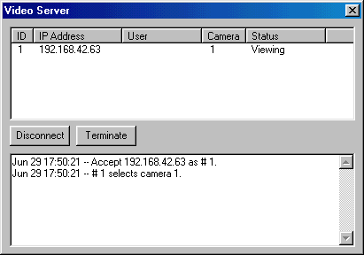

KVideo Server User Manager
An icon called DSR will be installed in the Windows Control Panel (click Start > Settings > Control Panel) once the DSR is installed.
Prior to use the DSR, the remote online view clients should be registered by using the Video Server User Manager.
Double click the DSR icon to invoke the DSR configuration dialog and start Video Server User Manager dialog box.
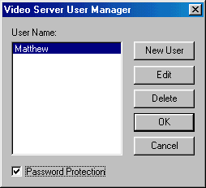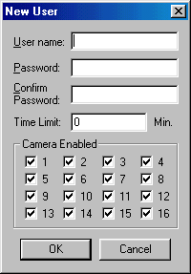

You can add new user, edit the existing user information or delete a user by clicking the appropriate buttons.
Check the Password Protection box in the botton to enable the password protection of the server. There will be no password protection necessary for all the user to come in if the Password Protection check box is not checked.
Each user entry has a name, password, time limit for continuous logon and the camera restriction information settings.

$+Recording
#KStorage Drive

For “Normal” mode of operation:

DSR will automatically detect available fixed hard disk(s) in the unit for recording.

For “Archive” mode of operation:

DSR will directly record into the active removable hard disk in the unit

Notes: The active (selected) drive should be assigned properly before the overall backup and restore operation is executed. Assign the target drive inside the “Insert drive” message box by clicking the “Swap Drive” button while the system is operated in “Archive” backup mode. Go to the “Option Setting” chapter for further detail.

#KTypes of Recording
According to the recording initiation method, four different types of recording are available in DSR:
- Instant recording
- Scheduled recording
- Pre-alarm recording
- Alarm recording

#KMultiple Camera Recording
- All cameras can be recorded independently.
- Each camera will be recorded into individual video file(s).
- The camera ID, start date/time, and the recording mode of the individual camera will be logged with database management.

#KRecorder Control Panel
DSR has a “RECORDER” panel to let the user interact with the unit for recording control with enough indication.

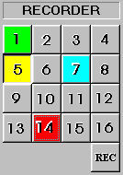

There are sixteen camera buttons in the “RECORDER” panel, all of which can be toggled on or off.
Each button provides different colors to indicate different types of recording and the status.
The available indicator colors are red, light blue, yellow and green respectively.
Only one type of recording is possible to each camera at one time and the priority of the recording type is as the following table respectively.

Red | Alarm recording, which is initiated by the alarm input or by motion detection.
Light blue | Indicate the Pre-alarm function of that camera.
Yellow | Instant recording, which is initiated by clicking the camera button on the recorder panel manually.
Green | Scheduled recording, which is controlled and started by the programmable timer.

#KInstant Recording
- Instant recording is the most interactive way and easy to use recording method.
- It is designed to start recording instantly to capture some unexpected special events.
- It works as a complement of the scheduled recording.
- You can simply toggle on or off the video recording by clicking the camera button on the “RECORDING” panel.
- The down button with a yellow light indicator indicates that the camera is under instant recording.
- Instant recording parameters of each camera can be programmed.
- Please see the section of Instant Recording Setting for parameter setup.

Note:
The instant recording video will be chopped into 15 minutes length files automatically in order to keep the record files at an accessible size.

Tip:
Instant recording can be used to work in a fast frame rate for short time recording while scheduled recording is expected to work in a lower frame rate for longer time recording.

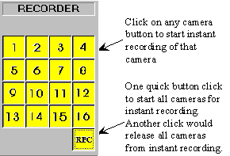

#KInstant Recording on Remote Client Workstation
Instant recording of the video (camera) of the on-line view at the remote client workstation is now available. For detail of this usage, please refer to the User Manual of the Intelligent Remote Player.

Note:
Please refer to the Section 3 and Section 4 of the DSR Installation Guide for detail instruction on System setup for remote viewing and Playback as well as the setup for remote dial-up connection.

#KAlarm Recording
- Alarm recording will be triggered by the alarm inputs or the motion detection.
- Sixteen alarm inputs are assigned one to one corresponding to the 16 cameras.
- Once the alarm is triggered either by the alarm input or the motion detection, the corresponding camera will start recording automatically.
- A red indicator indicates that the camera is now under alarm recording.
- The alarm recording function of an individual camera can be disabled; also the alarm recording duration and the frame rate of each camera can be programmed individually.
- Please see the section of Alarm Recording Setting for the setup details.

Note:
Only the logon username of “SUPER” can access the utility for alarm enable and alarm recording parameter settings.

#KPre-Alarm Recording
- Pre-alarm recording works together with the alarm recording, which enables you to capture images before the alarm event is happened.
- Pre-alarm allows images to be temporarily recorded for a short period of time (1 to 60 second) at normal situation. Once an alarm is being triggered, the pre-alarm images become permanent files, which can be retrieved and playback.
- Using “Play Back” function can playback the pre-alarm images.
- The pre-alarm function is setup in the “Alarm”, “Recorder Setting” inside “Utility”.
- You can activate the pre-alarm function accordingly when the alarm function is selected.
- Please see the section of Pre-Alarm Recording Setting for the setup details.

Note:
Pre-alarm images are stored into two temporary files alternatively under normal situation. Therefore, when alarm is being triggered, there will be two pre-alarm files accompanies with the alarm file.

Tip:
Pre-alarm recording provides an effective way of using the hard disk storage:
- The pre-alarm images will be kept in the hard disk permanently only when an alarm is actually taken place.
- It provides image before the alarm, you can review what is happening before the alarm was being triggered and it use lesser hard drive space than doing schedule recording at all time.

#KScheduled Alarm and Motion Detection
A programmable timer is implemented for scheduled alarm and motion detection.
Please see Scheduled Alarm and Motion Detection Setting in the Utility->Recorder Setting section for the set up.

#KScheduled Recording
- A programmable timer is implemented for scheduled recording.
- DSR supports both weekday and weekend scheduled recording.
- The timer will start and stop scheduled recording automatically according to your input.
- A green indicator indicates the camera, which is recording under the timer control.
- The default recording duration value is 0, which represents infinity or continue recording.
- During schedule recording, you can manually over ride to instant recording mode by pressing down the camera button on the Recorder Panel. The indicator will change to yellow to indicate that the camera is under instant recording.
- However, it will automatically resume scheduled recording once you click the camera button to turn off instant recording of that camera. The indicator will then resume to green.
- Please see Scheduled Recording Setting in the Utility->Recorder Setting section for the setup and implementation example of the schedule recording.

Note:
Only the logon username of “SUPER” can access the utility for configuring settings of scheduled recording parameters.

Note:
The schedule recording video will be chopped into 15 minutes length files automatically in order to keep the record files at an accessible size.

#KRecording with Audio
(Upgraded feature)
DSR provides audio function to one of the cameras for recording.
User can install a microphone to the DSR through a sound card connection.
To setup audio recording, please refer to the attaching audio to camera of the Utility->Option Setting Menu.

Before you can activate this function, you will need to have a Sound (Capture) board installed and properly configured to the DSR Digital Surveillance Recorder, as follows:
- Click Start-> Programs-> Accessory -> Entertainment (Multimedia, for Windows 95)-> Volume Control, Click Properties from the Options Menu. Select the Playback check: Make sure the Microphone option is selected from the “Show all volume control” list box. Click apply and OK, then make sure the Microphone is Muted at Playback.
- Repeat the same steps for Recording, only for this time, the Microphone (or any other input port you may choose as an input feed to the sound board as the recording source) is selected in this case.
You will need to adjust the volume of input and output by using the sound recorder, which is built in with the Windows 98 Operating System.

K#Audio Input From DSR Video Card(s)
(New feature)
Other than using the sound card, the new DSR video capture card(s) with audio phone jack, can provide additional audio input channel(s).
Each card provides one audio channel that can be attached to any selected camera(s) for recording.

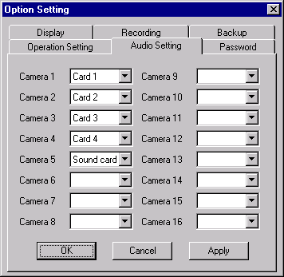
Note:
This feature is reserved for future release use.

#$K+Archive Mode
Considering the total process of recording and backup of the videos, we can come up with two different configurations:

Normal Mode - | The DSR Digital Surveillance Recorder will record video into the Fixed Hard Drive (s).  As required, you can backup the recorded video to a Removable IDE drive via the Housekeeping function from the Utility Menu. The raw copy of video can optionally be deleted during the backup process.
Archive Mode - | The DSR Digital Surveillance Recorder will record video into the assigned Removable IDE Hard Drive(s).  When it is about full, it can be removed from the recorder physically for additional archiving to DAT or other backup media. The DSR Digital Surveillance Recorder will maintain continuous recording to an alternate removable drive during the archiving operation. When the videos inside a Removable drive are obsolete, they can be erased immediately before video recording is resumed on this drive.

The recording configuration of the DSR should be selected at the very beginning of overall system operation.
The normal mode is set by default. To switch to the Archive mode, please refer to the Backup Function of the Options Setting Menu.
You will need to have two removable IDE hard drives configured in the DSR to support this mode of system operation.
The DSR application needs to be closed and restart to apply the mode switching from each other

Note:
To configure an IDE hard drive to become a removable hard drive: -
Click Start->Settings->Control Panel->System->Device Manager->Disk Drives->GENERIC IDE DISK TYPE XX->Properties->Settings->in Options check the Removable box to enable the IDE to be removable.

#KSwap Drive
Make sure the system is properly setup with two available “Removable Hard drive” and there is a fixed hard drive to support system operations.
Click the Swap Drive button in the Main Screen and then the “Swap drive” message box will appear as shown in the following Figure.
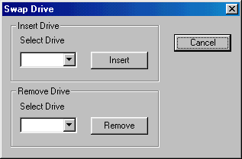

Click the down arrow in the Select drive dialog box next to the Remove button to display the registered removable drive(s) for removal and select the desired drive. Click Remove button and follow the pop up instruction to complete the REMOVE process.
The removed hard drive can put into another machine and the entire drive can be back up (Archive) to other long term storage media such as the DAT or equivalent device with huge storage capacity but may not work as fast. This operation on a dismounted drive can be down off-line (while the DSR is closed) or in a separate PC workstation.

#KRe-insertion of Removable Drive
Click the Swap Drive button in the Main Screen and then the “Swap drive” message box will appear as shown in Figure above.
Click the down arrow in the Select drive dialog box next to the Insert button to display the registered removable drive(s) for insertion and select the desired drive. Click Insert button and follow the pop up instruction to complete the INSERTION (RE-Insertion) process.
If a blank new drive is inserted in the slot, make sure it is of the same make and configuration as the removed drive for proper operation.

$#K+Playback the Video
Recorded video in all hard disk(s) can be retrieved for playback.

#KVideo Player
(Upgraded feature)
- Click the “Play Back” button in the DSR to invoke the video player.
- The video player provides interactive video search and frame operations to playback the recorded video files.

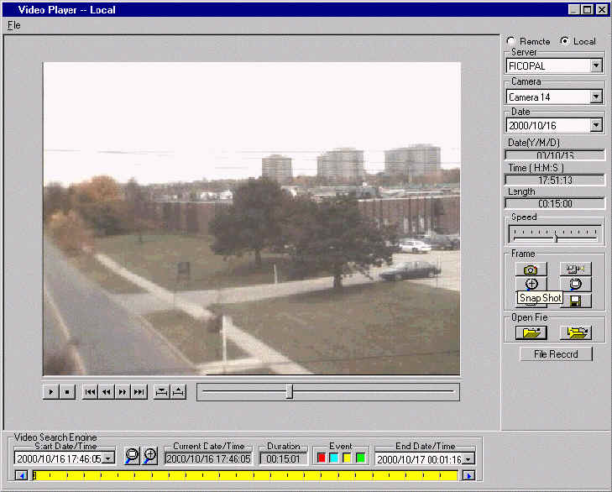

Playback the files which are stored inside local machine
- Select "Local" radio button in the top right hand corner of the video player to playback the files stored inside local machine.
- Available server name with recorded video inside the local machine become selectable by clicking the down arrow in the server selection control.
- Available camera under the selected server name become selectable by clicking the down arrow button in the camera selection control.
- Available date under the selected camera become selectable by clicking the down arrow button in the date selection control.
- Available video will be populated into the video search engine.
- User click the "File Record" button to show the available video by file names and information display in a list control box.
- Click the header button of the column of each key field will sort and display that field in different order. For example, user can click "Start Time" header button once to sort the files to display in assending order and click it again to sort it back to descending order.
- Select the video file you want to playback by clicking at the File Record list or at the Search Engine.
- The selected file will be high lighted both at the File Record list and at the Search Engine in synchronize.
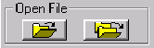
- Click the left Open File button (open one file icon) to playback the selected file.
- Click the right Open File button (open serial files icon) to playback the selected file and the successive files automatically.

Playback the files which are stored inside a remote machine through LAN connection
(Upgraded feature)
The video files can be playback in another LAN connected machine with a very fast access time.
It is rather to playback in a remote machine than in the local server machine if the server machine is busy doing recording.

Prerequisite:
Share the DSR-video folder(s) in the server machine as shown in the following table:

Folder Name | Share Name
c:\DSR-video | dsr-video
d:\DSR-video | dsr-videod
e:\DSR-video | dsr-videoe
… | …
i:\DSR-video | dsr-videoi
… | …

The client machine should logon with a user name, which is also known by the server machine. In the server machine (NT platform), click start->programs->user manager and add the user name into the user table.
The client machine should be able to browse the DSR-Video folder(s) in the server machine. In the client machine, double click the Network Neighborhood->select the server machine to see the DSR-Video folder(s) is available.

- Select "Remote" radio button in the top right hand corner of the video player.
- A "Input Server" dialog will pop up to allow input the remote server name to logon.
- Input remote server name or use the Borwse function to seek for the remote server name, click OK when finished.
- Available server name with recorded video inside the remote machine become selectable by clicking the down arrow in the server selection control.
- Available camera under the selected server name become selectable by clicking the down arrow button in the camera selection control.
- Available date under the selected camera become selectable by clicking the down arrow button in the date selection control.
- The available video will be populated into the video search engine.
- User click the "File Record" button to show the available video by file names and information display in a list control box.
- Click the header button of the column of each key field will sort and display that field in different order. For example, user can click "Start Time" header button once to sort the files to display in assending order and click it again to sort it back to descending order.
- Select the video file you want to playback by clicking at the File Record list or at the Search Engine.
- The selected file will be high lighted both at the File Record list and at the Search Engine in synchronize.
- Click the left Open File button (open one file icon) to playback the selected file.
- Click the right Open File button (open serial files icon) to playback the selected file and the successive files automatically.

Download Video File Into Local Machine:
(Upgraded feature)
- Right click a filename inside the Record File list control window, select "Download" and the selected file will be downloaded into the local machine.
- The downloaded files can be playback later under "Local" machine playback.

#KList File Record
- Click the “File Record” button in the Video Player Dialog Menu bar to display the list of video files for the selected camera. Click on the desired file from the list and Click Open File Button to start the playback.
- The video file selected will be loaded and played automatically.
- The File List will change as the video search engine is manipulated, to match with only those files appear on the video bar window. Click the Reset Button in the Search Engine to resume the List of all files.

#KVideo Playback Controls
Use the video playback controls beneath the video image to control the video playback function.
- User can stop the video and use the scroll bar to search the video if needed.
- Press the “two-arrow” keys to advance one frame at a time.

#KPlayback Camera Control
Using the camera title control box can select the camera by name or title for playback. Click the downward arrow and click the desired camera for playback.
During other playback operation, repeat the same procedure to select the new desired camera for playback, the playback action of the previously selected camera will terminate.

(Simultaneous playback of two or more recorded videos is possible by invoking the playback operation from the main menu but this is not recommended.)

#KAbsolute Date/Time and Length Display
The absolute date/time of the playback and the length of the video will be displayed on the control panel.

#KPlayback Speed Control
Using the sliding control box can adjust the playback speed. Drag the control button to the right side to increase the playing speed. Drag it left to decrease the playing speed. The normal playback speed is indicated in the speed control box when the control button is put in the middle.

#KRewind and Replay
Using the Begin/end Marker can select a portion of the current video file to be replay in a loop. Drag the scroll bar (Scroll bar for manual search) to the desired beginning position, click the “Begin” button to enter the marker, then repeat the process to enter the “end” position with the “end” marker button. Click “Play’ button to begin the playback with auto-rewind.

#KFrame Mode for Print and Save a Frame
Click “Snap shot” button to grab a frame from the video and enter the frame operation mode.

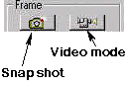
User can select area of interest using mouse movement and the mouse left button and then click “Zoom” button to zoom in the image. Click “Unzoom” to return to normal display.
Click the “Print” button to print out the image captured.
The frame can be saved to floppy disk in drive A by clicking the “Save” button.
The saved filename has the following format:

x-mmddyy-hhmmss.bmp
x: | camera number
mmddyy: | month/day/year
hhmmss: | hour:minute:second
bmp: | bmp file extension

Tip:
The user can set up printer properties for printing hard copy and previewing the hard copy before actual printing.

#KReturn to Video Mode
Click the “Video mode” button to go back to video playback mode.

$+#KVideo Search Engine

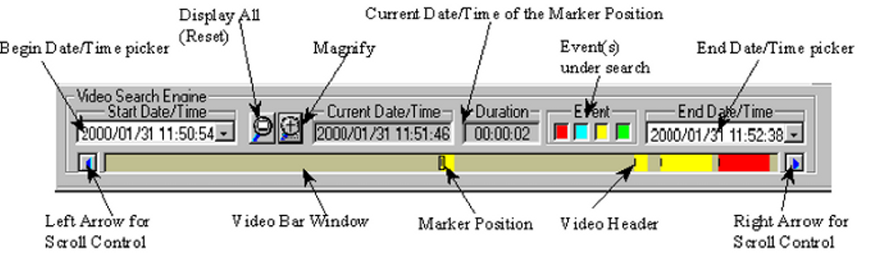

The Video Search Engine is a independent functional block for searching of the recorded video of a camera interactively.
Two date/time pickers are used for begin and end date/time input and indication.
All the available recorded videos within this date/time limits will be presented inside the video bar window.
Different types of video will be presented in different colors as follows:

Red | - | Alarm recording
Light Blue | - | Pre-alarm recording video
Yellow | - | Instance recording video
Green | - | Schedule recording video

Presses down the event-search button(s) to select types of event under search, they are color coded in the same manner of the events. By default all types are selected when the Player is activated.
A marker, which is a small rectangle box inside the video bar window, marks the “video header” position of the selected video.
Point the mouse cursor and click inside the video bar window, the video marker will snap to the nearest “video header” position of a video file.
A date/time display box in the middle of the video search engine displays the current date/time value of the marker position.

#KPlayback the Current File
Click the “Open Single file” icon button to open the marked video for viewing.
Once the button is pressed down, the video will be playback until the end of the file is reached.

#KOpen the Video Files and Playback Continuously
Click the “Open Multiple files” icon button to open the marked video for viewing.
Once the icon button is pressed down, the videos will playback one by one continuously. Or user can click the “Open Multiple files” icon button to release the button to disable the continuous playback.

#KSearch the Recorded Video Interactively
User can directly input the begin/end date/time by using the “begin and end date/time picker” to select interesting portion of the video bar window to show in more detail.
User can also use the mouse click to mark the interesting “video header” and then click the “Magnify +” icon to magnify the interesting portion.
Use the left and right arrow icon buttons to scroll the video bar window.
Repeat the mark and magnify actions to search for the video of interest.
Click the “Magnify all (Reset)” icon to resume to present all available video.

#$K+Motion Detection
An advanced digital video-processing algorithm is used to implement motion detection function in DSR. The motion detection function is designed to automatically detect any activities within a selected detection area(s), and to start recording of that camera when activity is detected inside the detection area(s).

#KSetup the Motion Detection
Right clicks the mouse button on the video screen of the camera you want to set motion detection.
A “Motion detection setting” dialog box will pop up for motion detection setting.

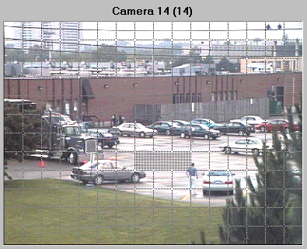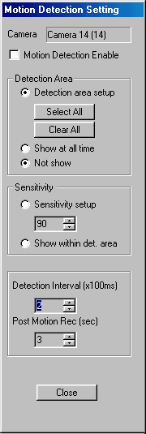

#KSet Detection Area
The first thing to do is to input the detection area(s).
Click the “Detection area setup” button to show the grid on video screen for detection area selection. Simply click on any spot to select/de-select the grid(s) to form detection area(s) of any shape in the video screen for motion detection.
The “Select all” button is used to rapidly select the whole video screen for detection.
The “Clear all” button is used to de-select all the selected areas.

#KIndicate the Detection Area
If you want the detection area to be presented on the video screen during normal operation, click the “Show at all time” button.
If you don’t want the detection area to be presented in the video screen during normal operation, click the “Not show” button.

#KSet Sensitivity for Motion Detection
Click the “Sensitivity setup” button to display the “activity blocks” for sensitivity setup.
The “activity blocks” will superimpose on the moving object to highlight the activities on the video screen.
You can adjust the sensitivity by using the sensitivity control box. Click the up arrow button to increase the sensitivity and click the down arrow button to decrease the detection sensitivity respectively.
The sensitivity value display inside the control box, which is an arbitrary value, indicates the relative detection sensitivity.
Adjust the sensitivity by monitoring the “activity blocks” on the screen to determine that the sensitivity is adjusted to an optimal condition for motion detection and without false alarm.
User can check the “Show within detection area” button to confine the “activity blocks” only to display within the detection areas you have selected.

#KDetection Interval
The occurrence of motion is detected by correlating the successive frames of the video. The “Detection interval” control box can adjust the detection interval between these successive frames. The detection interval is in unit of 100mS.
The default value is at 200mS.

#KRecording Time Extension
The motion detected in the detection area(s) will be used as an event to trigger the alarm recording of the corresponding camera.
Once the recording is started, it will continue with an extension time even the motion is stopped.
This extension time can be adjusted by using the “Post motion rec.” control box.
The time interval is in unit of second show inside the control box and the default value is 3 seconds.

#KEnable the Motion Detection Function
Check the “Motion detection enable” box to enable the motion detection function once you have set all the parameters.
(User can temporarily disable the motion detection by uncheck the “Motion detection enable” box. All the settings of the motion detection will stay unchanged, which let the user to enable the motion detection back again afterward more easy).
Click the “Close” button; the corresponding camera button in the display panel will light up with a yellow grid indicator to indicate the motion detection function.
The detection area will be presented in the video screen if the “Show at all time” button is checked.

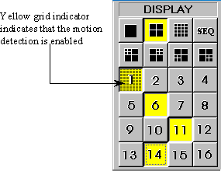

#KTips
- Use motion detection recording instead of using schedule recording in order to effectively use of the recorder’s storage space.
- Think of using the motion detection in the low activity area and let DSR to monitor the area for you.
- Motion detection when works with the search engine allows you to playback the useful video more easily.
- Set up the motion detection correctly to prevent too many false alarms to happen.
- Think of using the alarm scheduler to arm the motion detection so that it can start at say after office hour.

$K#+Alarm status indication
(New feature)
- In order to indicate the alarm status (hardwire alarm and the motion detection alarm) clearly, indicators are added to the "Recorder" and "Display" control buttons in the front panel.
- The status indicators in the "Display" control buttons are for motion detection status indication.
- The status indicators in the "Recorder" control buttons are for alarm status indication.
- The indicator will light up if the alarm or motion detection is enabled.
- There have three possible alarm statuses, which are no alarm set, alarm set but out of scheduled time and alarm armed.
- Grey color of the indicator means no alarm is set.
- Red color of the indicator means that the alarm or the motion detection is armed, the alarm recording can be triggered at any time.
- Blue color of the indicator means that the alarm or the motion detection is being set but the alarm scheduler inhibit the alarm to arm when it is out of the scheduled time.

Motion detection status indicator | 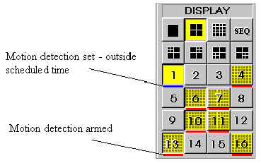
Alarm status indicator | 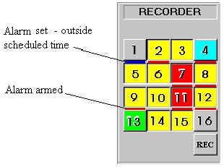

#$K+Pan-Tilt Zoom Control
Local and Remote Pan/Tilt/Zoom Control
(Upgraded feature)
Use the pan-tilt zoom function, the camera can zoom in or out to adjust the view angle of the camera for a better image, or it can pan and tilt the camera to different position of interest for better surveillance.

PTZ control hardware enable and configuration
Go to Control Panel to invoke the DSR configuration to enable and set up the correct PTZ control hardware protocol to allow PTZ control.

PTZ control user account
Go to Control Panel to invoke the DSR configuration to set up the PTZ control user account prior to allow remote user logon for PTZ control.

PTZ control server/client operation
A PTZ control server is implemented in order to allow user to logon to do PTZ control. The PTZ control server allows only one user logon at a time.
TCP/IP protocol is used for the server client connection.

The PTZ Control Server | The PTZ control server will be available once the DSR is running, waiting for client to logon.  Press the Ctrl-Alt-3 keys to pop up the PTZ server dialog box.  Or Right click the PTZ icon inside task bar to restore GUI of the PTZ server.  The current status will be displayed in the dialog box with username, priority level and the address of the current user.  You can click the Disconnect button to terminate the current usage.  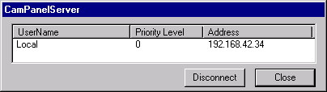
The Client PTZ Control Panel | Client PTZ control panel is used for local and remote PTZ control.  Local User:  A client PTZ control panel will be available in the DSR machine once the DSR is running. Local client PTZ control panel will be granted with the highest priority level.  Click the PTZ icon button besides the “EXIT” button to activate the PTZ panel.  When user clicks the PTZ icon button, the PTZ control panel will pop up and logon to the PTZ control server automatically.  Local user can do PTZ control at any time in first priority, any other user will be disconnected when local PTZ panel pop up.  Remote User:  However, a client PTZ control panel start in a remote machine other than the DSR server machine, user should logon to the PTZ control server to gain access the PTZ function.  Right click the PTZ icon in the upper left corner of the PTZ Panel to invoke the server and user logon dialog box to logon.  Note:  The user name should be added to the PTZ user account prior to allow user logon.  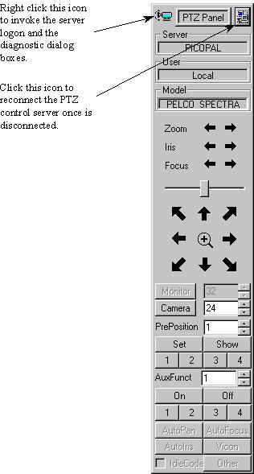

#KCamera Selection
The camera selection box in the PTZ control panel is for selecting the desired camera for PTZ control.

Note:
The camera number setting of the On Site Receiver Driver (OSRD) should be set up correctly with the same camera number as the camera attached to it.

#KMonitor Selection
While the MV912RS switcher protocol is selected, there will be a monitor selection box in the PTZ control panel.
The monitor selection box is for monitor selection.
In order to control PTZ of the desired camera through switcher, you should select the monitor number and the camera number accordingly prior to do so.

#KSpeed Control
The speed of movement of the pan-tilt head can be controlled. The slide bar is to control the speed of movement.

#KPan-Tilt Zoom Control
Once the camera is selected, click the arrow buttons for corresponding direction movement, the focus and zoom control.

#KPre-Position
The positions of the pan tilt head can be saved so that camera can repeat its position when wanted.

Set Pre-position
Use the “Pre-position” box to enter the pre-position number.
Once the number is selected, pan/tilt the camera to a desired position and then, press “Set” button to assign this position into that particular pre-position number.

Show Pre-position
Use the “Pre-position” box to enter the pre-position number.
Once the number is selected, press the “Show” button to send the camera to the saved pre-position.

Pre-position hot keys
Four hot keys are implemented for four frequently used pre-positions.
Once programmed, press these hot keys will send the camera to it’s pre-position accordingly.

$+#KAlarm Alert Modules
Alarm Alert modules are designed to work with the DSR.
Once the DSR receives an alarm triggering, either from alarm inputs or motion detection, it will activate the alarm alert modules to alert the outside world.
The alarm alert application consists of two software modules, the Alarm Alert Caller and the Alarm Alert Receiver.
The Alarm Alert Caller runs with the DSR unit and the Alarm Alert Receiver is installed in the remote machine.
The alarm alert signal can reach the remote machine through dial-up connection, LAN connection or through Internet connection.

K#Alarm Alert Configuration

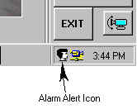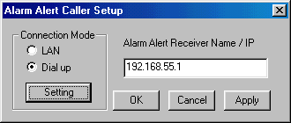

Through Dial-up connection | Alarm Alert Caller setup in DSR unit  - Prior to use the DSR software, make a New Connection for the remote unit inside the Dial-Up Networking folder.  - Please refer to the Appendix of How to Setup a Dial-up Connection in order to set up the DSR unit as a Dial-up client machine.  - After the DSR software is started, press the "Windows" button in the keyboard to show the task bar.  - Right click the Alarm Alert icon in the task bar to show the Alarm Alert Caller Setup window.  - Select Dial up in the Connection Mode.  - Click the Setting button to show the Dial-up connection window.  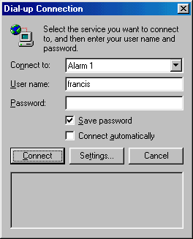  - Inside the Connect to input box, click the down arrow to select connection from the available connection name inside the Dial-up Networking folder.  - *Make sure to check the Save password box.  - Input the IP address of the remote unit in the Alarm Alert Receiver Name/IP box.  - Click Apply and OK to end set up.  Alarm Alert Receiver setup in Remote unit  - A Dial-up Server should be installed in the remote unit to allow the remote unit to receive telephone call.  - The Dial-up Adapter of the remote unit should have TCP/IP protocol attached and with a fixed IP address assigned by the administrator.  - Please refer to the Appendix of How to Setup a Dial-up Connection in order to set up the remote unit as a Dial-up server machine.
Through LAN connection | Alarm Alert Caller setup in DSR unit  - DSR should have the LAN connection correctly setup so that it can see the remote unit inside its Network Neighborhood.  - After the DSR software is started, press the "Windows" button in the keyboard to show the task bar.  - Right click the Alarm Alert icon in the task bar to show the Alarm Alert Caller Setup window.  - Select LAN in the Connection Mode.  - Input the computer name or the IP address of the remote unit in the Alarm Alert Receiver Name/IP box.  Alarm Alert Receiver setup in Remote unit  - The remote unit should have a Computer name and Workgroup assigned correctly, so that other machines within the LAN can see it in their Network Neighborhood.  - The LAN card adapter of the remote unit should have TCP/IP protocol attached with the IP address assigned to it automatically at start up.
Through Internet connection | Alarm Alert Caller setup in DSR unit  - The DSR unit should be connected to the Internet through its ISP.  - After the DSR software is started, press the "Windows" button in the keyboard to show the task bar.  - Right click the Alarm Alert icon in the task bar to show the Alarm Alert Caller Setup window.  - Select LAN in the Connection Mode.  - Input the domain name or IP address of the remote unit in the Alarm Alert Receiver Name/IP box.  Alarm Alert Receiver setup in Remote unit  - Make connection to the Internet  - The remote unit should be assigned with a fixed IP address automatically by the ISP or the remote unit has a static domain name.

#KAlarm Alert Receiver in the Remote Machine
The Alarm Alert Receiver usually come with the Remote Intelligent Player and will be installed with the Remote Intelligent Player in the remote machine.

Start the alarm alert receiver
- Double click the Alarm Receiver icon to start the Alarm Alert Receiver module.
- A small Alarm Alert Receiver icon will shown inside the task bar of the Desktop window.
- User can right click the Alarm Alert icon and click restore to show the Alarm Alert display window manually.

Alarm operation
- The Alarm Receiver window will pop up automatically when DSR alarm occur.
- The alarm camera and DSR IP address will be displayed with the date/time info.
- Double click the camera number to invoke online view of the alarm camera.
- Click Acknowledge to stop the alert signal.
- Click Hide to hide the Alarm Alert reciever window.

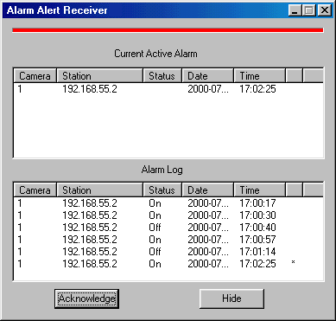

Note:
To make sure (diagnose) the system and network are correctly set up for the Alarm Alert function: - the DSR station should be able to ping the IP address of the remote client unit.

$K#+DSR Configuration at Control Panel
(New feature)
- In order to seamlessly integrate the DSR with the Windows environment, a DSR configuration icon is implemented in the Control Panel of the server machine.
- User can go to the Control Panel (Start->Settings->Control Panel) and double click the DSR configuration icon to invoke the DSR configuration dialog.
- A "Logon" dialog box will pop up for password protection. User uses the SUPER as username and the corresponding password to logon for DSR configuration operation.
- User can configure the DSR prior to run the DSR program.

The available DSR configuration setting are listed in the following table:

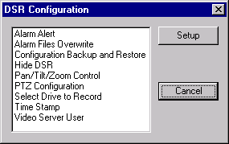

K#Alarm Alert Enable
Enable the Alarm Alert function.

K#Alarm Files Overwrite Enable
By default, the alarm files will not be deleted during circular mode. However, user can check the enable box in the dialog to allow oldest alarm files to be deleted during circular recording.
Note:
Motion detection triggered and hardwire triggered alarm files are treated equally as alarm files.

K#Configuration backup and restore
This utility allows user backup the DSR configuration prior to install or re-installs the DSR software in order to prevent loss of configuration data. Also, a DSR configuration template disk can be prepared for easy DSR setup during mass production.
The configuration parameters to be backup includes the following items:
- Camera title, enable/disable
- System settings
- Recorder settings
- Motion detection settings
- System retain parameters
- Alarm schedule (the one which is currently in use)

K#Hide DSR
A "Minimize" button will be placed on the top right hand corner of the DSR display window frame.
User clicks the "Minimize" button to hide the DSR display window.

K#PTZ control Enable
Enable the PTZ function.

K#Configure the PTZ control
KPTZ User Account Management
Only one user is allowed to operate the PTZ control at a time, a user account with priority level should be setup for management. Click "Add" button to add a new user with priority level. The highest level is 1. Select a user and click "Remove" or "Edit" button to remove or edit the user input respectively.

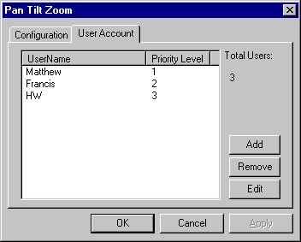

KPTZ Control Hardware Configuration
Select the PTZ receiver driver protocol, RS232 port number, Baud rate (9600 as default value), data (8 bit as default value), parity (none as default value), stop bit (1 bit as default value) and flow control.

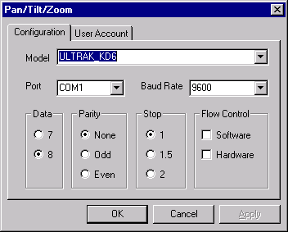

KPTZ Driver Model Setting
Select the Model item, a drop down menu will show up the available models.

Note :
Following list are the current PTZ control protocols supported by DSR.

Model | Protocol/OSRD/Connection Interface
KALATEL_KTD312 | KTD-312 computer interface ASCII Protocol, RS-232 to RS-232
PELCO_ASCII | Pelco ASCII Protocol (Revision G), RS-232 to RS-422/485
PELCO_SPECTRA | Pelco "D" Protocol, RS-232 to RS-422/485
PHILIPS_AUTODOME | PHILIPS (BURLE) Auto Dome RS-232 to RS-422/485 LTC0809 Series
UEL_MV912RS | UEL OSRD model of MV912RS
UEL_MV961A | UEL OSRD model of MV961A, MV561  PHILIPS (BURLE) On-Site Receiver/Driver, RS-232 to Biphase LTC8561 Series :  LTC8564/20  LTC8566 Series
ULTRAK_KD6 | Ultrak KD6 Auto Dome
VICON_SURVEYOR99 | V5UWM , VICON Surveyor99 Camera Dome RS-232 to RS-422/485 Surveyor99 Series

Note:
The DSR unit provides only RS-232 output connection, all other serial connections by external converter are provided by the user themselves.

KPTZ Control Serial Port Setting
The port setting is about the COM port (the serial port) connection preferences.
The default of the connection preferences is as the above figure.
Please refer to individual OSRD connection preferences for correct setup of the connection preferences.

K#Select Hard Drive to Record and Disk Space Utilization Control
Select Hard Drive(s) to Record

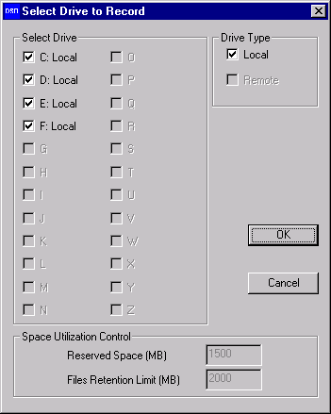

- Default to use all available hard drive(s) for recording.
- The C: drive is used for system and memory swapping, it is recommended not to use it for video recording.
- It is recommended to install hard drive(s) with at least 15GB for recording.

Disk Space Utilization Control
- Two parameters are being used for disk space utilization control, which are "Reserved Space" and "File Retention Limit".
- The minimum value of "Reserved Space" and "File Retention Limit" are 1.5GB and 2.0GB respectively.
- The "Reserved Space" and "File Retention Limit" values will be increased to 7% and 10% of the disk capacity respectively, when bigger disk capacity is being used.
- Increase the value of these parameters will increase the safety margin in order to provide more reliable recording performance.

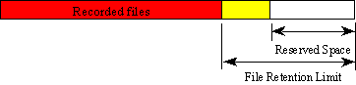

Linear recording mode:
Recording will stop automatically when all the selected hard drives' available space is lower than the "Reserved Space" value.
Circular recording mode:
A separate process for deletion will be started automatically to delete the oldest files when all the selected hard drives' available space is lower than the "Reserved Space" value. The delete file process will recover the disk space until it reaches the "File Retention Limit" value.

K#Time Stamp Enable
User selects and enables date and time overlay to each camera for display and recording.

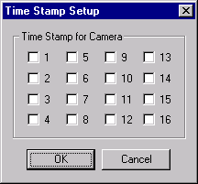

K#Video Server User Manager
Prior to use the DSR, the remote online view clients should be registered through the Video Server User Manager.
Double click the Video Server to invoke the Video Server User Manager dialog box.

Check the Password Protection box in the botton to enable the password protection of the server. There will be no password protection for the user to come in if the Password Protection check box is not checked.
You can add new user, edit the existing user information or delete a user by clicking the appropriate buttons.

Each user entry has a name, password, time limit for continuous logon and the camera restriction information settings.

$+Utility Functions
#KAccess to Utility Functions
When the user logged on as “SUPER”, he/she is authorized to use the Utility functions.
However, if the user logged on as “OPERATOR”, the Utility button will be disabled to prevent the password and some other system and recording settings from being modified by the operator.
Click on the Utility button on the main screen, and the Utility menu will then pop up as shown below.

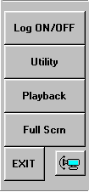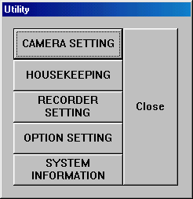

#KRe-Activate the Disabled Housekeeping Functions
When operating under “Archive” mode, the Housekeeping Function of the Utility Menu will be disabled. To activate those build-in housekeeping functions from DSR, switch the system back to “Normal” backup mode. Go to the Option Setting Chapter for further details.

#$K+Utility - Camera Setting
#KCamera Title Assignment
To assign the Camera title correctly for individual camera connected to the DSR unit, click the “Utility” button and then select the “Camera Setting” button for camera title input. A camera setting dialog box (as seen in Figure 13) will be displayed for camera title input.
The default camera title is Camera 1 to Camera 16 respectively.
Click the desired input area for data entry, and then input the camera title accordingly. User can use the Backspace and Del keys in the keyboard to edit the text in the input field.

#KMaximum No. of Camera Imposed by Software
The max. no. of cameras is limited to 4 for model 104 and 8 for model 208 etc. This is to match with the design no. of cameras shown in the corresponding part of the generic model no. The camera assignment check box(es) will turn to Grey color and no manual assignment is possible.

#KCheck the Active Connected Cameras
The “Active” check box must be UNchecked for the non-connected camera inputs.
When the “Active” check box is unchecked to the Cam ID, then the corresponding buttons in the “Display” and “Recorder” panels will be disabled to stop the display and recording function of these camera inputs.

#KApply the Camera Title
Click the “Apply” button to apply the camera titles right away.
Click OK to confirm the inputs and close the dialog box.
Or you can click “Cancel” button to close the dialog box without change.
The camera title will be displayed on the screen to indicate the camera title.
The camera title will also be used for the video playback search.
The camera number buttons will be disabled in the “Display” and “Recorder” panels for the non-connected camera inputs.

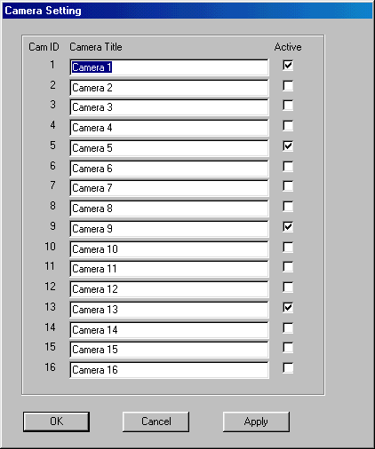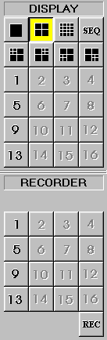

#$K+Utility - Recorder Setting
#KRecording Parameters
Each recording mode has their individual sets of recording parameter settings.
Click the “Utility” button and then select the “Recording Setting” to start program the recording parameters of individual cameras for different recording modes.

#KFrame Rate
(Upgraded feature)
Frame rate is the most important parameter for recording setting.
The value of frame rate is in f/s (frame per second), which controls how many frames will be recorded for every second.
A broader selection of lower frame rate is provided in this version.
For PAL system, the available frame rates for recording are 25, 12.5, 8, 4, 1, 1/2, 1/3, 1/5, 1/10, 1/15, 1/30, 1/60 frame/second.
For NTSC system, the available frame rate for recording are 30, 15, 7.5, 4, 1, 1/2, 1/3, 1/5, 1/10, 1/15, 1/30, 1/60 frame/second.

Note:
The actual frame rate of recording will be same as this setting if the system resource at the condition taken care of other system setting permits. However, the DSR may regard this setting as the target maximum frame rate.

#KInstant Recording Setting
- Select the Instant tab inside the Recording Setting menu and a screen similar to that of Figure 14 is shown.
- Input the desired frame per second for individual cameras.
- The default frame rate is 25 frames per second.
- Click OK to confirm the input and close the dialog box or click the X box in the upper right corner to close the dialog box after use.

Tip:

Eight frames per second or above is recommended for instant recording to capture real-time video.

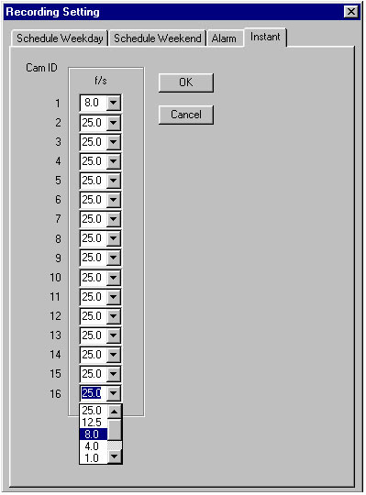

#KAlarm Recording Setting
- Select the Alarm tab inside the Recording Setting menu
- Check the “ON” box of the corresponding camera to enable the alarm input and the alarm recording function.
- Input the alarm recording duration in the (in sec) column.
- Check the NOpen (Normally Open) box if the switch connected to the alarm input is a normally opened switch.
- Input the frame per second for individual cameras. The default frame rate is 25 f/s.

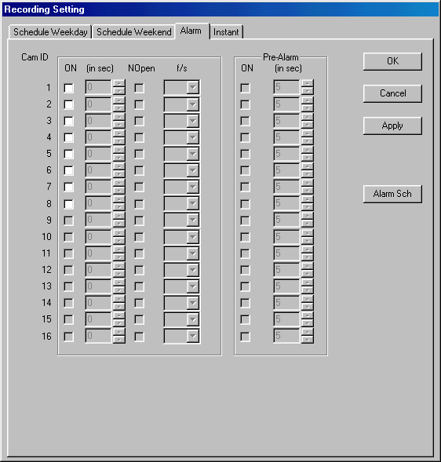

#KPre-Alarm Recording Setting
- Pre-alarm recording function will be available once the alarm enable box is checked.
- Check the “ON” box in the pre-alarm column to enable the pre-alarm function of the corresponding camera(s).
- Input the pre-alarm duration from one to 60 seconds.
- Every time when the alarm is triggered, the pre-alarm recording image will be saved into a permanent file, which can be retrieved for playback.
- Click OK to confirm the input.

Tip:
Pre-alarm lets you review images prior to the actual happening of the alarm event. Also, pre-alarm keep the images only when the alarm is actually taking place, so that storage space can be used more effectively. This mode is more effective than that in scheduled recording.

#KScheduled Alarm and Motion Detection Setting
- Click the "Alarm Sch" button to enter the alarm scheduler.
- Check the camera box to enable the alarm schedule function to apply to the camera.
- When a camera is not checked, the alarm schedule function will not apply to this camera. The motion detection and alarm input function will trigger the alarm recording as usual.
- The entire camera check box are unchecked as default.
- Input a time slot for each checked camera. The alarm recording function will be enabled at this time slot every day.
- The start and stop time set at 0 means the alarm function will work all the time.
- User can save the schedule as a file name or to open an existing schedule by clicking the File button in the upper left hand corner.

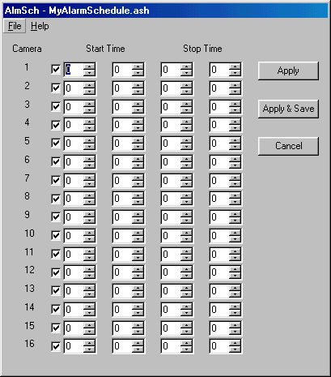

#KScheduled Weekday Recording Setting
- Select the Schedule Weekday tab inside the Recording Setting menu.
- Check the camera you want to record.
- Input the start time and the end time for scheduled weekday recording.
- Input the frame per second for individual cameras.
- The default frame rate is 1 frame per second.

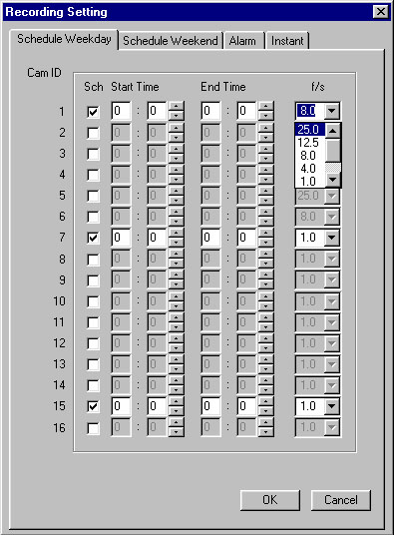

Note:
- The start time and end time is needed for scheduled recording.
- The input time is in the 24-hour HH:MM format.
- The factory default setting of the weekday recording start time is 0:0 and the default end time is also 0:0.
- Under this default setting, the camera will start at Monday 0:0 and end at Tuesday 0:0 and then start right away at Tuesday 0:0 and repeat all over again for the rest of the weekdays. Therefore, weekday recording will record at all times from Monday 0:0 through Saturday 0:0.
- Weekend scheduled recording also has the default 0:0 start time and 0:0 end time.
- Under default start and end time the unit will start recording at Saturday 0:0 and end at Monday 0:0.

#KScheduled Weekend Recording Setting
- Select the Schedule Weekend tab inside the Recording Setting menu.
- Check the camera you want to record.
- Input the start time and the end time for scheduled weekend recording.
- Input the frame per second for individual cameras.
- The default frame rate is 1 frame per second.

Tip:
Scheduled recording is a background recording activity of the recorder. A lower frame rate for scheduled recording will much prolong the recording time. It is recommended to use frame rates of four frames per second or lower for scheduled recording.

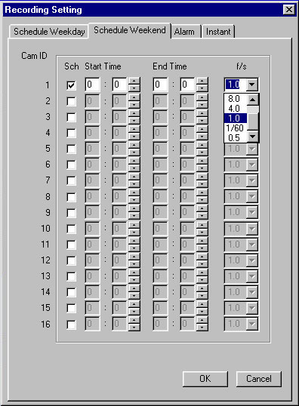

#KExample 1
Suppose you want to start and stop your recording on one camera within the same day every weekday, say 9:00 to 17:00 from Monday to Friday. You should go to the schedule weekday recording menu, check on the desired camera, enter 9:00 in the start time input, 17:00 in the end time input, then enter the frame rate you want and finally click OK to confirm.
You will see the green indicator light of that camera in the RECORDER panel at 9:00 to 17:00 to indicate that scheduled recording is taking place.

#KExample 2
Suppose you want to start recording one camera at 18:00 and stop at 6:00 the next day, for everyday from Monday to Friday.
You should go to the schedule weekday recording menu, check on the desired camera, enter 18:00 in the start time input, 6:00 in the end time input, then enter the frame rate you want and finally click OK to confirm.
In this case, the recorder will start at Monday 18:00 and then stop at Tuesday 6:00 and the schedule continues every weekday. While on Friday, the recorder would start at 18:00 as usual but it would stop on Saturday at 0:0.
Therefore, you should enter another schedule for weekend recording to fit your scheduled planning as a whole.

$#K+Utility - Option Setting
#KDisplay Sequencing
Click “Utility”, “Option Setting” and then “Display” to get to the sequence display menu.
Enter the dwell time for sequencing duration. The default dwell time is 1 second.
Check the camera(s) you want to display during sequencing.
Click Apply to apply the input parameters right away.
Click OK to confirm and close the dialog box.
For sequencing operation please see the “Display” section of this manual.

Example:

The cameras 3, 4, 5, 7, 8, 9, 12, 13, 14, 15, 16 are checked in the following Figure.

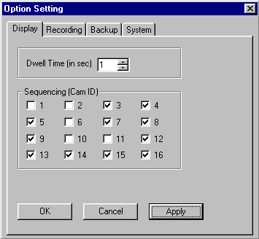

While in the 1-Screen mode, the sequence will be performed as follows:

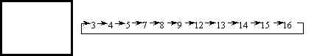

While in the 4-Screen mode, the sequence will be performed as follows:

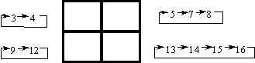

#KImage Resolution for All Recording
Select the Recording tab in the Option Setting menu.
The Resolution check box controls the image resolution for recording.

 | PAL system | NTSC system
Super recording mode set the recording in the full resolution | 640 pixels by 480 pixels | 640 pixels by 480 pixels
High recording mode set the recording in a standard resolution CIF | 384 pixels by 288 pixels | 320 by 240 pixels
Low recording mode set the recording in a low resolution QCIF | 192 pixels by 144 pixels | 160 by 120 pixels

Tip
Check the “High” box in Resolution for most of the case. It is to optimize the system performance and storage usage.

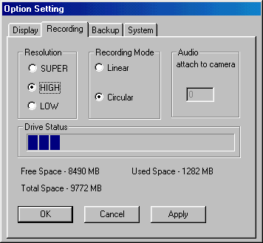

#KRecording mode selection

Linear recording mode:
When linear mode is selected for recording, the recording (alarm, pre-alarm, instance and schedule) will stop automatically when the storage device(s) is all used.

Circular recording mode:
When circular mode is selected, the recording will keep on by automatically over writing the oldest files once the storage device(s) is full. However, the alarm image file(s) will be protected in this mode.

#KAttach Audio to a Camera
(Upgraded feature)
For Models with Audio Recording support only, make sure the system is properly set up for audio recording, equipped with an audio pickup device and have the volume control setup for both recording an playback etc. Use the GUI to setup the audio attachment to each camera accordingly.

#KDrive Capacity
The total space, free space and the used space of the selected drive are displayed simultaneously.
A progress bar is displayed to indicate the usage level of the recorder drive graphically.

#KBackup Function
Make sure to select the intended Backup Mode prior the formal use of the DSR system for routine video recording.

#KNormal Mode
Make sure to select the backup drive prior to the backup.
Click on Utility, then Option setting, and finally the Backup tab.
The system is set to “Normal” backup mode as system default.
Click the down arrow in the backup drive box to display the available removable drive(s) for backup and select the desired backup drive.
The removable device can be a DVD-RAM drive or a removable IDE hard drive.
The user can choose to keep copies on hard disk after backup or not.
Click Apply to confirm and click OK to close the dialog box.

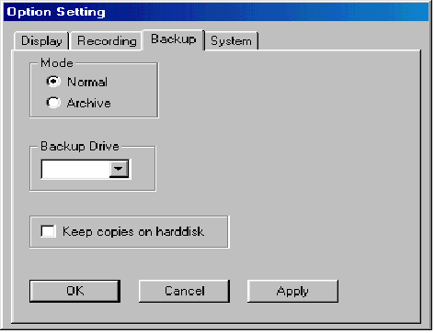

#KArchive Mode
To switch to “Archive” mode, check Archive in Mode, then Apply and OK. The DSR application should closed and restarted to effect the change. At the start up on Archive backup mode, the main screen of the DSR will be slightly modified with a new "Swap Drive" button in the recorder panel and two status bars for the removable drives are added in the bottom of the screen as shown in following Figure.

Red – Indicates the drive is active, which is being used for video recording.
Green – Indicates the drive is dismounted, ready for physically taken out.

#KSystem Operation Data
Click on the System tab in Option Setting menu

KPassword Setting
There are two default usernames for DSR: SUPER and OPERATOR.
Two passwords can be introduced for security use during the logon session. The users should input the correct password to logon to the system.

KDate/Time Display Format
You can select the date/time display format to 12-hour or 24-hour format.
Click Apply to confirm the input, click OK to confirm and exit or click Cancel to exit without any changes.

#KLogoff Selection
Check the “Continue display” box if you want the image to continue displayed at logoff condition.
Check the "Continue recording" box if you want the instant recording still function upon logoff.
Check the "Continue PTZ" box if you want to allow PTZ upon logoff.

KOperation Setting
(New feature)
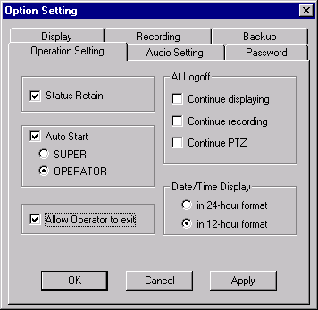

#KStatus Retain
The current status (viewing and recording modes) will be retained and will be restored when DSR start up next time if the "Status Retain" is checked.

K#Auto Start
Check the Auto Start to enable DSR to start automatically. The logon process will be skipped when DSR start up next time. You should select to auto start and logon as "Super" or "Operator".

K#Allow OPERATOR to exit
When checked, the "Exit" button will be available to the OPERATOR logon user.

$+#KUtility - Housekeeping
(Upgraded feature)
#KBackup
Click Utility, Housekeeping then backup to open the backup menu.
Check the file(s) you want to backup by clicking on the file list, or you can backup all files by checking the "Select all files" box.
You can keep copies on the hard disk after backup by checking the “Keep copies on harddisk” box.
If you want to clean up old files in the backup device prior to do backup, check the “Delete all files in the backup device” box.
Click the “Start” button to start the backup process.

Note:
The Housekeeping Menu is disabled when the system is set to “Archive” Backup mode, To revert it to “NORMAL” mode, go to the Options Setting chapter for further details.

KBackup Progress Indicator
A progress bar will be shown at the bottom of the main screen to indicate the backup progress. The number of files to backup and the progress will be indicated accordingly.

Tip:

You can use the Preview function of the unit to playback video.

#KRemove Video Files
Click Utility, Housekeeping and then Remove tab.
Click the down arrow in the server box to select server name.
Click the down arrow in the camera box to select camera.
Click the down arrow in the date box to select date.

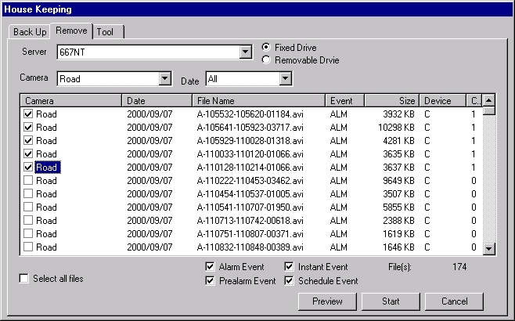

Check the file(s) to delete by clicking on the camera title or you can check the “Select all files” box to delete all files.
Click Start button to execute the file delete function.
The video files will be deleted to spare storage space.

Note:

Display format

Camera | The camera column displays the corresponding camera titles
Date/Time | The date/time column displays the record starting date and time
Event | “SCH”, “REC” and “ALM” represents schedule, instant and alarm recording events respectively.
Filename | The filename has the following format:

video file name: | type - start_time - end_time - frame . avi (avi file)
type: | A is Alarm recording
 | P is Pre-alarm recording
 | R is Instant recording
 | S is Schedule recording
start_time: | recording start_time in hhmmss format
end_time: | recording end_time in hhmmss format
frame: | number of frames in the file

#KHousekeeping Tools
Click on the Tools tab to enter the tools utility.
Users are recommended to use the “Run Scan Disk” and “Run Disk Defragmenter” functions on a frequent basis to optimize and debug the storage device(s) being used.

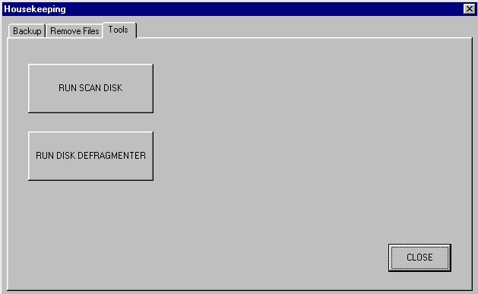

#KSystem Information
Click the System Information button to display the “About Digital Surveillance Recorder” message box, which shows relevant information about the DSR.

$+KWorking at Logoff
#KLog Off
Click the Log ON/OFF button on the main screen to log off.
The EXIT button is disabled during log off to prevent accidental or unauthorized termination of the surveillance function.

Note:

You should re-logon with the correct password to regain operation of the unit after logoff.

KDisplay During Log Off
For logoff display selection, go to the System Menu of Option Settings, check the "Continue Display" box if you want the image to be continually displayed after logoff.
If you do not check the "Continue Display" box, once logged off, the unit will not show any video images and the DSR logo will then be displayed on the screen.

#KRecording During Log Off

Alarm & schedule recording
The alarm and scheduled recording functions of the unit will keep on working during the logged off period.

Instant recording
In the System Menu of Option Settings, check the “Logoff continue recording” box if you want the instant recording function to be continually functioning after logoff.

#KTransmission during Log Off
DSR will continue transmission for remote online view even if the unit is under the logged off condition.

Note:
To disable transmission via Dial-in, you have to turn off the Modem (by switch or by disabling the Modem driver). Please see detail instruction as mentioned under the Remote On-line Viewing and Playback Recorded Video section.

KPTZ During Log Off
Go to the System Menu of Option Settings, check the Continue PTZ box if you want the PTZ function to remain after logoff.

$K+System Maintenance
#KSchedule Backup and Remove the Video File
The video files in the DSR unit should be backup and remove in a regular basis with a properly setup schedule.
This will insure that the performance of the DSR unit is working under its optimum condition.
It is also a vital procedure to prevent from data lose due to out of storage space of the hard drive.

#$K+Typical Hardware Configuration

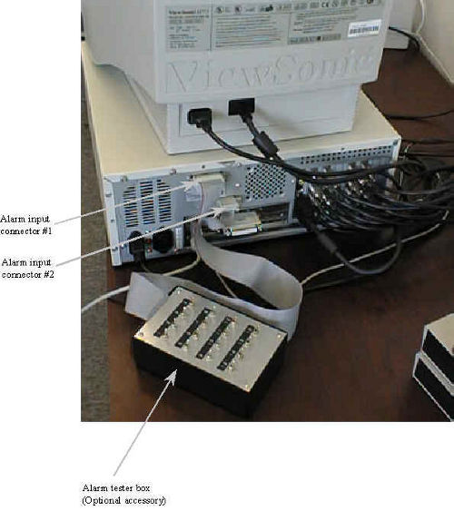

#KRear Panel
(Shown as Model 416)

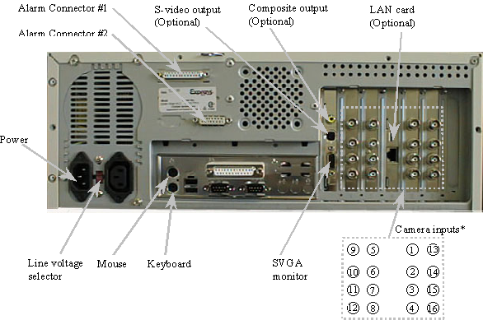

Camera Inputs

Connect the Camera(s) to the camera inputs and go to Camera Setting in the Utility to set up the camera parameters, which includes active camera connection enabling and the camera title assignment.

Tip:
Make sure that the “Active” box is unchecked for the non-connected camera(s), in order to perform the optimum video quality.

#$K+Alarm I/O Connection

External view of connectors

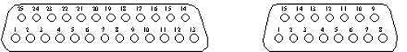

Alarm Connector #1 |  | Alarm Connector #2

Pin No. | Designations |  | Pin No. | Designations
1 | Alarm input 1 |  | 1 | Alarm input 13
2 | Alarm input 2 |  | 2 | Alarm input 14
3 | Alarm input 3 |  | 3 | Alarm input 15
4 | Alarm input 4 |  | 4 | Alarm input 16
5 | Alarm input 5 |  | 5 | Alarm output 1
6 | Alarm input 6 |  | 6 | Alarm output 2
7 | Alarm input 7 |  | 7 | Alarm output 3
8 | Alarm input 8 |  | 8 | N.C.
9 | Alarm input 9 |  | 9 | Gnd
10 | Alarm input 10 |  | 10 | Gnd
11 | Alarm input 11 |  | 11 | Gnd
12 | Alarm input 12 |  | 12 | Gnd
13 | N.C. |  | 13 | Gnd
14 | Gnd |  | 14 | Gnd
15 | Gnd |  | 15 | Gnd
16 | Gnd
17 | Gnd
18 | Gnd
19 | Gnd
20 | Gnd
21 | Gnd
22 | Gnd
23 | Gnd
24 | Gnd
25 | Gnd

Electrical Specifications:

Alarm Inputs
- TTL inputs
- Allow for open/close contact switch connection

Alarm Outputs
- Open collector output
- High impedance at normal
- Sink current at alarm

Alarm Output Configurations:

 | Hardwire Alarm Output | Motion Detection Alarm Output
Alarm Output 1 (pin 5) | Yes | Yes
Alarm Output 2 (pin 6) | Yes | No
Alarm Output 3 (pin 7) | No | Yes

#KColor Code Of Alarm Input And Output Cables

1. | 24-core cable (Blue ring) to connector #1 (DB25 female connector)  Alarm Inputs #1 to 12  Color Code for 24-core cable (Blue Ring):

 | Pin 1-Alarm #1 input: R/Or | Pin 14-Alarm #1 ground: Wh/G
 | Pin 2-Alarm #2 input: Bk/G | Pin 15-Alarm #2 ground: Wh-Bk/R
 | Pin 3-Alarm #3 input: Bk/R | Pin 16-Alarm #3 ground: Wh/R
 | Pin 4-Alarm #4 input: Bk/Or | Pin 17-Alarm #4 ground: Wh/Bl
 | Pin 5-Alarm #5 input: R/Bl | Pin 18-Alarm #5 ground: R/Bk
 | Pin 6-Alarm #6 input: Bk | Pin 19-Alarm #6 ground: Wh/G
 | Pin 7-Alarm #7 input: Wh | Pin 20-Alarm #7 ground: Bk/Bl
 | Pin 8-Alarm #8 input: G/R | Pin 21-Alarm #8 ground: Bl
 | Pin 9-Alarm #9 input: G/Or | Pin 22-Alarm #9 ground: R/Wh
 | Pin 10-Alarm #10 input: Or | Pin 23-Alarm #10 ground: Bk/Wh
 | Pin 11-Alarm #11 input: Wh-R/Bk | Pin 24-Alarm #11 ground: G
 | Pin 12-Alarm #12 input: Bk-R/Wh | Pin 25-Alarm #12 ground: Wh/Bk
 | Pin 13-Not Used

2. | 8-core cable (Blue ring) to connector #2 (DB15 female connector)  Alarm Inputs #13 to 16  Color Code for 8-core cable (Blue Ring):

 | Pin 1-Alarm #13 input: R | Pin 9-Alarm #13 ground: Bk
 | Pin 2-Alarm #14 input: Y | Pin 10-Alarm #14 ground: Wh
 | Pin 3-Alarm #15 input: Or | Pin 11-Alarm #15 ground: Br
 | Pin 4-Alarm #16 input: G | Pin 12-Alarm #16 ground: Bl

3. | 6-core cable (Yellow ring) to connector #2 (DB15 female connector)  Alarm inputs #1 to 3  Color Code for 6-core cable (Yellow Ring):

 | Pin 5-Alarm #1 output: R | Pin 13-Alarm #1 ground: Br
 | Pin 6-Alarm #2 output: G | Pin 14-Alarm #2 ground: Bk
 | Pin 7-Alarm #3 output: Wh | Pin 15-Alarm #3 ground: Bl
 | Pin 8-Not Used

Abbreviation:
R-Red | G-Green | Wh-White | Bl-Blue | Bk-Black
Br-Brown | Or-Orange | Y-Yellow

#$+KAppendix - How to Setup a Dial-up Connection
#KDial-up Server Machine Setting
A Dial-up Server is a machine to receive telephone call in order to create a dial-up connection for a dial-up client machine.

Network Configuration | Click Start->Settings->Control Panel->Network->Configuration  Make sure the following items have been installed  - Client for Microsoft Networks  - Dial-Up Adapter  - NetBEUI->Dial-UP Adapter  - TCP/IP->Dial-Up Adapter
Network Identification | Click Start->Settings->Control Panel->Network->Identification  Make sure to input a computer name and the workgroup.
Install Dial-up Server | - Click Start->Settings->Control Panel->Add/Remove Programs->Windows Setup->Communications->Details  - Make sure the “Dial-up Server” box having been checked, then click “OK”, and “Apply”;  - Insert your 98 Setup CD onto your CD-ROM, then click “OK”;  - Dial-up Server should be installed successfully after files copying is done.
Configure the Dial-up Server | - Double click My computer->Dial-Up Networking->Connections(in the menu bar)->Dial-Up Server  - Check the “Allow caller access” option box, click “Server Type”, a “Server Types” dialog box appears;  - Select “PPP: Internet, Windows NT, Windows 98” option from “Type of dial-up Server” combo box, and uncheck the “Required encrypted password” box , then click “OK”;  - Click “Apply”, then “OK”.
TCP/IP Setup for the Dial-up Adapter | - Click Start->Settings->Control Panel->Network->Configuration  - Highlight the “TCP/IP->Dial-up Adapter” item, then click “properties”, a “TCP/IP properties information” message box pops up, click “OK”, a “TCP/IP properties” dialog box will appear;  - Make sure the “IP Address” Tab is selected;  - *Check the “Specify an IP address” option, enter “192.168.55.1” as an example to the IP Address entry, enter “255.255.255.0” to the Subnet Mask entry;  - Click “OK” twice, a copy file dialog box will appear, you may require to insert the Windows98 SE Installation CD-ROM for system files update.  - Restart the computer.

#KDial-up Client Machine Setting
A dial-up client machine is a machine to create a dial-up connection by making a telephone call to the dial-up server.

Network Configuration | Click Start->Settings->Control Panel->Network->Configuration  Make sure the following items have been installed  - Client for Microsoft Networks  - Dial-Up Adapter  - NetBEUI->Dial-UP Adapter  - TCP/IP->Dial-Up Adapter
Network Identification | Click Start->Settings->Control Panel->Network->Identification  Make sure to input a computer name and the workgroup.
Make a New Dial-up Connection | Double click My computer->Dial-Up Networking->Connections(in the menu bar)->Make New Connection  Input to the following boxes  - Type a name for the computer you are dialing  - Select a modem  - Area code  - Telephone number  - Country code  A new connection icon with the computer name to call will appear
Configure the new connection | Right click the new icon with the computer to call->Properties->Server Types  - Select type of dial-up servers as PPP, Internet, Windows NT Server, Windows 98  - Check Log on to network  - Check Enable software compression  - Check NetBEUI  - Check TCP/IP  You can assign a fixed IP address to your machine for dialup connection, which will make sure the connection to work as long as you don't create an IP address assignment conflict.  Click TCP/IP Settings ->Specify the IP address  *Enter 192.168.55.2  Click OK

*If you are using an existing network workstation, please consult your network administrator for the correct setting.

$#+KAppendix - Making Sure You Have a Good Connection
If you are having connection problems, you can try using the ping command. Ping sends out a request to see if a certain computer at a given IP address is indeed there. After you have made a connection (a dial-up, LAN or Internet) open a Windows DOS session (click Start->Programs->MS-DOS Prompt). Type ping 192.168.42.63. This is the IP address for a computer in your LAN. If ping works, your TCP/IP stack and connection to the target machine is working.
You can type ping 204.71.200.75, which is the IP address for www.Yahoo.com (the web server at Yahoo.com). If ping works, your connection to the Internet is working.

$+#KAppendix - Find Out Your IP Address
You can use winipcfg command to display your current TCP/IP configuration.
To run the winipcfg command, Click Start->Run->typing winipcfg->OK

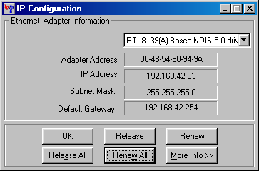

You can check the information for your LAN adapter (TCP/IP protocol bounded), your IP address which is 192.168.42.63 in this case, is automatically assigned by your network DHCP server. People in the LAN can ping you by using this IP address.

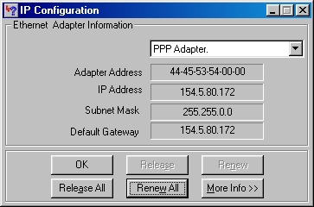

Other than the LAN adapter, you can also have the PPP adapter, which is your TCP/IP protocol bounded Dial-up adapter (your modem, in other word).
If your IP address is dynamically assigned by your ISP, the IP address field and the subnet mask field will be filled with zeros. As soon as you make a Dial-Up Networking connection, you are assigned an IP address. To find out what it is, run winipcfg and click the Renew All button.
People in the Dial-Up Networking connection can ping you by using this IP address.

# IDH_Overview
$ Overview
K Overview
+ auto
# IDH_Standard_Features
K Standard Features
# IDH_Optional_Features
K Optional Features
$ Turn On The Power
+ auto
# IDH_Turn_On_The_Power
K Turn On The Power
# IDH_Logon
K Logon
# IDH_The_Main_Screen
K The Main Screen
$ Display Control Panel
+ auto
# IDH_Display_Control_Panel
K Display Control Panel
# IDH_1Screen_Mode
K 1-Screen Mode
# IDH_4Screen_Mode
K 4-Screen Mode
# IDH_MultiScreen_Mode
K Multi-Screen Mode
# IDH_8Screen_Mode
K 8-Screen Mode
# IDH_16Screen_Mode
K 16-Screen Mode
# IDH_Rapid_Zoom
K Rapid Zoom
# IDH_Full_Screen_Display
K Full Screen Display
# IDH_Sequence
K Sequence
$ Intelligent Remote Player
+ auto
# IDH_Intelligent_Remote_Player
K Intelligent Remote Player
# IDH_DSR_Folder_Sharing
K DSR Folder Sharing for Remote Playback
# IDH_DSR_Network_Configuration
K DSR Network Configuration for Remote Online View
$ Video Transmission Server Function
# IDH_Video_Transmission_Server_Function
K Video Transmission Server Function
+ auto
K Video Server Manager
$ Recording
+ auto
# IDH_Storage_Drive
K Storage Drive
# IDH_Types_of_Recording
K Types of Recording
# IDH_Multiple_Camera_Recording
K Multiple Camera Recording
# IDH_Recorder_Control_Panel
K Recorder Control Panel
# IDH_Instant_Recording
K Instant Recording
# IDH_Instant_Recording_On_Remote_Client_Workstation
K Instant Recording On Remote Client Workstation
# IDH_Alarm_Recording
K Alarm Recording
# IDH_PreAlarm_Recording
K Pre-Alarm Recording
# IDH_Scheduled_Alarm&Motion_Detection
K Scheduled Alarm and Motion Detection
# IDH_Scheduled_Recording
K Scheduled Recording
# IDH_Audio_Recording
K Recording with Audio
K Audio Input From DSR Video Card(s)
# IDH_Audio_from_UCC4
# IDH_Archive_Backup_System_Mode
$ Archive Backup System Mode
K Archive Backup System Mode
+ auto
# IDH_Swap_Drive
K Swap Drive
# IDH_Reinsertion_of_Removable_Drive
K Re-insertion of Removable Drive
$ Playback The Video
# IDH_Playback_The_Video
K Playback The Video
+ auto
# IDH_Video_Player
K Video Player
# IDH_List_File_Record
K List File Record
# IDH_Video_Playback_Controls
K Video Playback Controls
# IDH_Playback_Camera_Control
K Playback Camera Control
# IDH_Absolute_DateTime_and_Length_Display
K Absolute Date/Time and Length Display
# IDH_Playback_Speed_Control
K Playback Speed Control
# IDH_Rewind_and_Replay
K Rewind and Replay
# IDH_Frame_Mode_for_Print_and_Save_a_Frame
K Frame Mode for Print and Save a Frame
# IDH_Return_to_Video_Mode
K Return to Video Mode
$ Video Search Engine
+ auto
# IDH_Video_Search_Engine
K Video Search Engine
# IDH_Playback_the_Current_File
K Playback the Current File
# IDH_Open_the_Video_Files_and_Playback_Continuously
K Open the Video Files and Playback Continuously
# IDH_Search_The_Video_Interactively
K Search The Video Interactively
# IDH_Motion_Detection
$ Motion Detection
K Motion Detection
+ auto
# IDH_Setup_The_Motion_Detection
K Setup The Motion Detection
# IDH_Set_Detection_Area
K Set Detection Area
# IDH_Indicate_The_Detection_Area
K Indicate The Detection Area
# IDH_Set_Sensitivity_for_Motion_Detection
K Set Sensitivity for Motion Detection
# IDH_Detection_Interval
K Detection Interval
# IDH_Recording_Time_Extension
K Recording Time Extension
# IDH_Enable_The_Motion_Detection_Function
K Enable The Motion Detection Function
# IDH_Tips_Motion_Detection
K Tips (Motion Detection)
$ Alarm Status Indication
K Alarm Status Indication
# IDH_Alarm_Status_Indication
+ auto
# IDH_PanTilt_Zoom
$ Pan-Tilt Zoom
K Pan-Tilt Zoom
+ auto
# IDH_Camera_Selection
K Camera Selection
# IDH_Monitor_Selection
K Monitor Selection
# IDH_Speed_Control
K Speed Control
# IDH_PanTilt_Zoom_Control
K Pan-Tilt Zoom Control
# IDH_PrePosition
K Pre-Position
$ Alarm Alert Modules
+ auto
# IDH_Alarm_Alert_Modules
K Alarm Alert Modules
K Alarm Alert Configuration
# IDH_Alarm_Alert_Configuration
# IDH_Alarm_Alert_Receiver
K Alarm Alert Receiver in the Remote Machine
$ DSR Configuration at Control Panel
K DSR Configuration at Control Panel
# IDH_DSR_Config_at_Control_Panel
+ auto
K Alarm Alert Enable
# IDH_Alarm_Alert_Enable
K Alarm Files Overwrite Enable
# IDH_Alarm_Files_Overwrite_Enable
K Configuration backup and restore
# IDH_Configuration_backup_and_restore
K Hide DSR
# IDH_Hide_DSR
K PTZ control Enable
# IDH_PTZ_control_Enable
K Configure the PTZ control
# IDH_Configure_the_PTZ_control
K PTZ User Account Management
K PTZ Control Hardware Configuration
K PTZ Driver Model Setting
K Serial Port Setting for PTZ Control
K Select Hard Drive to Record and Disk Space Utilization Control
# IDH_Select_hard_drive_to_record_and_disk_space_utilization_control
K Time Stamp Enable
# IDH_Time_Stamp_Enable
K Video Server User Manager
# IDH_Video_Server_User_Manager
$ Access to Utility Functions
+ auto
# IDH_Access_to_Utility_Functions
K Access to Utility Functions
# IDH_ReActivate_The_Disabled_Housekeeping_Functions
K Re-Activate The Disabled Housekeeping Functions
# IDH_Camera_Setting
$ Camera Setting
K Camera Setting
+ auto
# IDH_Camera_Title_Assignment
K Camera Title Assignment
# IDH_Maximum_No_Of_Camera_Imposed_by_Software
K Maximum No. Of Camera Imposed by Software
# IDH_Check_The_Active_Connected_Cameras
K Check The Active Connected Cameras
# IDH_Apply_The_Camera_Title
K Apply The Camera Title
# IDH_Recorder_Setting
$ Recorder Setting
K Recorder Setting
+ auto
# IDH_The_Recording_Parameters
K Recording Parameters
# IDH_Frame_Rate
K Frame Rate
# IDH_Instant_Recording_Setting
K Instant Recording Setting
# IDH_Alarm_Recording_Setting
K Alarm Recording Setting
# IDH_PreAlarm_Recording_Setting
K Pre-Alarm Recording Setting
# IDH_Scheduled_Alarm&Motion_Detection_Setting
K Scheduled Alarm and Motion Detection Setting
# IDH_Scheduled_Weekday_Recording_Setting
K Scheduled Weekday Recording Setting
# IDH_Scheduled_Weekend_Recording_Setting
K Scheduled Weekend Recording Setting
# IDH_Example_1
K Example 1 (Scheduled Recording)
# IDH_Example_2
K Example 2 (Scheduled Recording)
$ Option Setting
# IDH_Option_Setting
K Option Setting
+ auto
# IDH_Display_Sequencing
K Display Sequencing
# IDH_Image_resolution_for_all_recording
K Image resolution for all recording
# IDH_Recording_mode_selection
K Recording mode selection
# IDH_Attach_Audio_to_Camera
K Attach Audio to Camera
# IDH_Drive_capacity
K Drive capacity
# IDH_Backup_function
K Backup function
# IDH_Normal_Mode
K Normal Mode
# IDH_Archive_Mode
K Archive Mode
# IDH_System_Operation_Data
K System Operation Data
K Password Setting
K Date/Time Display Format
# IDH_Logoff_Selection
K Logoff Selection
K Operation Setting
# IDH_Status_Retain
K Status Retain
K Auto Start
# IDH_Auto_Start
K Allow Operator to Exit
# IDH_Allow_Operator_Exit
$ Housekeeping
+ auto
# IDH_Housekeeping
K Housekeeping
# IDH_Backup
K Backup
K Backup Progress Indicator
# IDH_Remove_Video_Files
K Remove Video Files
# IDH_Housekeeping_Tools
K Housekeeping Tools
# IDH_System_Information
K System Information
$ Working at Logoff
+ auto
K Working at Logoff
# IDH_Log_Off
K Log Off
K Display During Log Off
# IDH_Recording_During_Log_Off
K Recording During Log Off
# IDH_Transmission_During_Log_Off
K Transmission During Log Off
K PTZ During Log Off
$ System Maintenance
K System Maintenance
+ auto
# IDH_Schedule_Backup_And_Remove_The_Video_File
K Schedule Backup And Remove The Video File
# IDH_Typical_Configuration
$ Typical Hardware Configuration
K Typical Hardware Configuration
+ auto
# IDH_Rear_Panel
K Rear Panel
# IDH_Alarm_Connection
$ Alarm I/O Connection
K Alarm I/O Connection
+ auto
# IDH_Color_Code_Of_Alarm_Input_And_Output_Cables
K Color Code Of Alarm Input And Output Cables
# IDH_ How_to_Setup_a_Dial-up_Connection
$ How to Setup a Dial-up Connection
+ auto
K How to Setup a Dial-up Connection
# IDH_Dial-up_Server_machine_setting
K Dial-up Server machine setting
# IDH_Dial-up_Client_Machine_Setting
K Dial-up Client Machine Setting
$ Making Sure You Have a Good Connection
# IDH_Making_Sure_You_Have_a_Good_Connection
+ auto
K Making Sure You Have a Good Connection
$ Find Out Your IP Address
+ auto
# IDH_Find_Out_Your_IP_Address
K Find Out Your IP Address

