Digital Surveillance Recorder
Intelligent Remote Player
User Manual

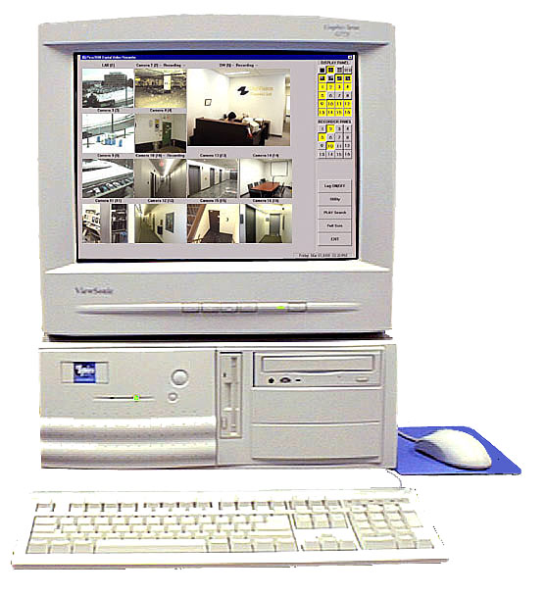

Table of Contents

Introduction 4
Overview 4
Standard Features 4
Optional features 4
Glossaries of Terms 4
DSR Remote Player Setup 5
Installation 5
Install Modem 5
Install Ethernet card 5
Make a new dial-up connection 5
Start the DSR remote player 6
Through telephone line 6
Select DSR Station 6
Select DSR server station 6
On-line Viewing 7
Start the DSR on-line viewing 7
Select DSR server station 7
(Via Dial-up) 7
Select viewing camera(s) 8
Select viewing server station 8
Viewing more than one DSR station at the same time 9
Resize of the viewing window 9
Configure the Video Compressor 9
Select the Resolution of transmitted image 10
Recording the Viewing Video 10
Close the viewing window 11
Playback the recorded video 12
Show the recorded video files 12
Filename format 12
Sort, select and play the video file 12
The DSR video player 13
Video playback controls 14
Absolute date/time and video length display 14
Playback speed control 14
Frame mode 14
Zoom 14
Print hard copy 14
Save a frame to floppy disk 14
Return to Video mode 14
Open a downloaded video file 15
Open a locally (Client Station) recorded video file 16
APPENDIX I 17
DSR Remote Player configuration 17
Database 17
Video files 17
Housekeeping of the video files 17
APPENDIX II 18
DSR Recorder configuration for remote playback and online viewing 18

This software is intended to use in the Local Area Networking system. Any machine in the same LAN with the DSR can be used to playback the recorded video or doing online viewing remotely by using this software.
Remote client also can be connected to the LAN through DSR telephone dial-up service.

Introduction

Overview | The DSR Intelligent Remote Player Application software plays an integral part with the DSR-series of Digital Surveillance Recorder to form a total Digital Surveillance Network system.
Standard Features | - Playback of Pre-recorded video files on a DSR Digital Recorder Station  - View listing of available video files prior download and playback  - Support PAL and NTSC standard  - Online Remote viewing of live video connected to the DSR Server Station  - Instant recording of on-line view (instantly received)  - Integrated video Player with comprehensive playback control (Stop, Pause, Play forward, Speed control, Video search)  - Video frame capture and print out  - Video Storage to floppy Disk for transport  - Support multiple mode of connectivity, LAN, PTSN and ISDN
Optional features | - Video Recording at Remote Client  - Compression control on video receiving for optimization of refresh rate and delay  - Internet connection for remote viewing, recording and playback
Glossaries of Terms | - Video Server – This refers to the DSR station which transmits the digital video data using the camera as direct input source or retrieve from the recorded video files.  - Video Client – Normally refer to the Remotely connected PC workstation with the DSR Intelligent Remote Player application installed. The System unit for DSR station can be used as a video client of another DSR station, however, please note that the DSR Main Screen is not designed to work with both application simultaneously. The user is responsible for working around for such operational setting.
 | - On-line View – Unlike the playback of recorded video, this refer to the instant view of the “live” video despite of some possible delay or lower refresh rate due to limited bandwidth of network and transmission process.
 | - Station ID -- The identification of a server or station in a network. Depending on the type of network media and protocol, the Station (Computer) name or the IP address will be applicable. The IP address is used in the TCP/IP type of transport protocol environment. It usually takes the from as xxx.xxx.xxx.xxx. When a station have more than one networking interface connectors, you have to put the one that is associated with the connection you are using. For example, for telephone dial up, please use the one associated with the Windows Dial-up Adapter (Driver).
 | - DSR Network Administrator -- As the networking system included the DSR server and client expands, it is the emerging role of Network system Administrator who will be responsible for the various designs on configuration of the network to avoid and resolve conflicting setup condition. (Such as for the assignment of IP address for internal or external accesses, the Name and Workgroup of the involved workstations and the use of Name Resolution Services).

DSR Remote Player Setup

Installation | Install the DSR remote player by run the setup program in the provided installation disk.  The remote (PC) station should work either in Windows 95 or Windows 98 with Microsoft IE5.0 and Microsoft Access installed.  After installation complete, a DSR remote player icon will be appeared on the desktop window.
Install Modem | Make sure to have a modem properly installed if you want to use the dial-up connection
Install Ethernet card | Make sure to have a PCI Ethernet card properly installed if you want to access the DSR system (server) via LAN
Make a new dial-up connection | If you want to use telephone Dial-up for remote access, you have to setup a dial-up connection using the Windows95 or Windows 98’s Dial-Up Networking function.  Go to My Computer, Dial-Up Networking, Connections, Make New Connection  - Input name for the computer you are dialing to connect : e.g. DSR,  Consult your DSR networking Administrator for the assigned Name if necessary  - Select a modem; enter the following data:  - Area code:  - Telephone number:  - Country code:  Go to My Computer, Dial-Up Networking, Right click the DSR icon, select Properties, select Server Types  - Type of Dial-Up Servers : PPP: Internet, Windows NT Server, Windows 98  - Check the Log on to network check box , if necessary.  - Check the Enable software compression check box  - Check the NetBEUI check box, if necessary
Note also:
Please refer to Section 3 of the DSR Installation Guide on basic setup for Remote Intelligent Playback and Section 4, Dial-Up Server/Client TCP/IP Setting for Windows98. The IP address assigned during the setup will be used as the Station ID here after.

Start the DSR remote player

DSR Remote Player Icon | Double click this icon to invoke a new start of the DSR Remote Player  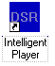
Through LAN | If the LAN is up and running, Double click the DSR remote player icon on the desktop window to invoke the DSR remote player.
Through telephone line | Go to My Computer, Dial-Up Networking and then double click the desired connection icon (e.g. DSR). A “Connect to” dialog box for the desired connection will pop-up, click the connect button to start the telephone dialing and connection. Once the dial-up networking is connected, Double click the DSR remote player icon on the desktop window to invoke the DSR remote player.

Select DSR Station

Select DSR server station | It is possible to have more than one DSR digital recorders in a LAN.  Click the “Browse…” button and a “Browse for Computer” dialog box will appear for you to select the desired DSR station from the LAN.  Tips  If you do not find the desired DSR station in the pop up window at the first place, Click the”+” sign next to the Entire Network Icon to expand the tree, locate the Workgroup where the DSR is assigned and expand it, then Select the DSR station and then click OK. You may need to consult your DSR Network Administrator for the assigned name if necessary.
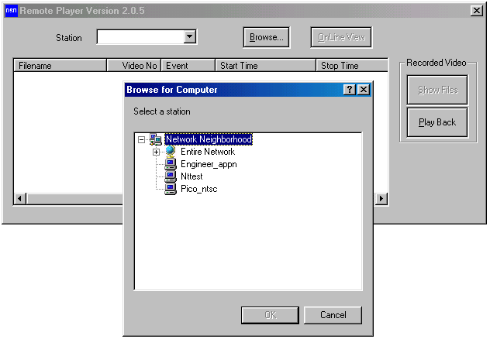

On-line Viewing

Start the DSR on-line viewing | Once the desired DSR station is selected, you can activate the on-line viewing function of the DSR by clicking the “OnLine View” button.  A new window for on-line viewing will pop up accordingly. The DSR Station name and the default camera name (initially assigned Camera 1) of viewing will be displayed as the caption of the window.
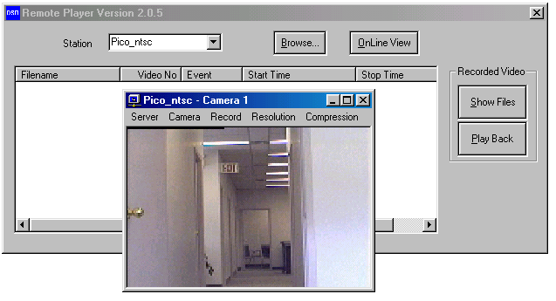

Select DSR server station  (Via Dial-up) | In case of access via Dial-up connection, you have to manually enter the IP address into the DSR Station entry box. (such as 192.168.42.34)  Tips  Again, you may need to consult your DSR Network Administrator for the assigned name if necessary.
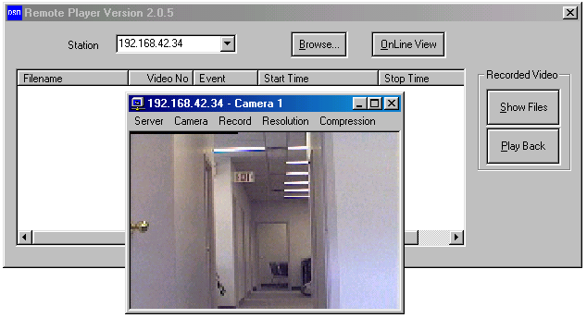

Select viewing camera(s) | Click “Camera” button inside the viewing window to select or change camera.  If you want to more than one camera in the Desktop Window, Open another viewing window for a new camera by clicking the “OnLine View” button again, and select another camera for viewing.
Select viewing server station | Click “Server” button inside the viewing window to select another server.  The Input Server Name or IP address Dialog Box appears, enter the IP address as required or select a Server Name by clicking the Browse button. Open the viewing window for a new server by clicking the “OK” button. If the server is not accessible, it will take several seconds before the message “Connection to server…..-failed” comes out. You may try with a different Station ID or consult your DSR network Administer to provide the other IP address
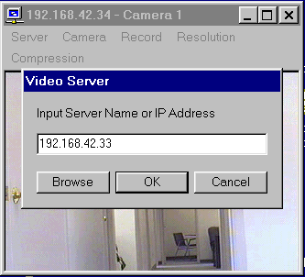

Viewing more than one DSR station at the same time | While the camera(s) of a DSR station is viewing, user can “Browse” another DSR station and start online viewing of the newly selected DSR station simultaneously. Or you may enter the IP address to the DSR station ID and click the OnLine View button to invoke the next window of camera view, as shown in the example below.

Resize of the viewing window | You can change the size of the viewing window by dragging the window at the edge or corner of the window or to click the “minimize” and “maximize” buttons to change the window size.  Click the “Resume” button to resume to the default (previous) size of the window.
Configure the Video Compressor | You can change the Compressor setting to optimize the OnLine Viewing performance to meet with your specific requirement. Activate the Compression Control dialog by clicking the” Compression” button; use the slide bar to adjust the index as follows:  Quality: from 0 to 100 (Highest)  Data Rate: Up to 60.oo kb/s can be set, consider matching it with the data transfer rate of the current networking performance.  Frame Rate: A max of 30 fps for NTSC or 25 fps for PAL system  Key frame rate: Enter 1 to 99 seconds  Click OK to confirm your selection, Cancel to return to the previous setting  After the selection complete, Click the Camera or Server button and select the existing or a new camera to see the effect of the new setting

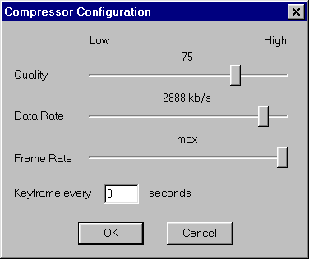

Select the Resolution of transmitted image | You can change the Resolution (the captured active pixels) setting to optimize the OnLine Viewing performance and duration of the video storage to meet with your specific requirement. Activate the Resolution Control dialog by clicking the ”Resolution” button; and select one of the following options  384x288 (PAL)  320x240 (NTSC)  192x144 (PAL)  160x120 NTSC  After the selection complete, Click the Camera or Server button and select the existing or a new camera to see the effect of the new setting
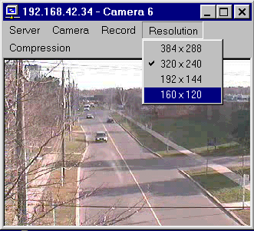

Recording the Viewing Video | You can Record the video under OnLine View by clicking the Record -> Start button. To stop the video recording,, click Record -> Stop . All the other control function on the menu of the Receiver will be suspended during the video recording period.  The recorded video is stored in a folder, bearing the camera name and created under the c:\DSR\image\{DSR station ID}\{camera title} folder. Please refer to the Open a locally (Client Station) recorded video file, in the following section.

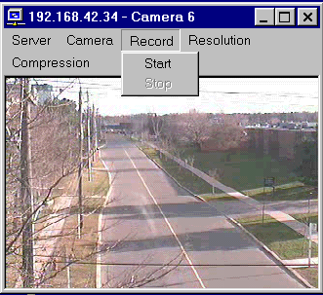

Close the viewing window | Click the “X” button to close the viewing window.

Playback the recorded video

Show the recorded video files  (From Server) | Upon the selection of DSR station complete (by browse for the station name or entering the IP address)  Click the “Show Files” button to retrieve the available video files from the selected DSR station.  The available video files of that DSR station will be displayed inside a list control box with scroll bars to scroll around for file access.
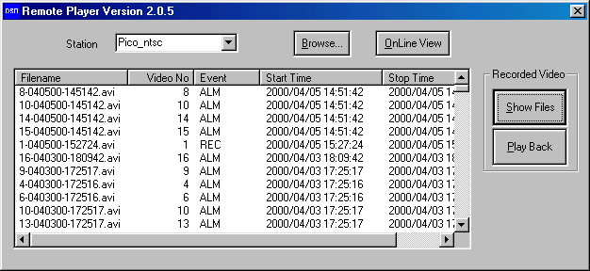

Filename format | The filename has the following format:  x-mmddyy-hhmmss.avi  x: camera number  mmddyy: month/day/year (record start date)  hhmmss: hour:minute:second (record start time)  avi: filename extension
Sort, select and play the video file  (Video stored in Server Station) | User can click on the column’s top button to sort the list by using of that column as sorting key field.  Click the desired filename for high light and then click “Play Back” to start playback.  Or double click the desired file to start playback.  The selected video file will be down loaded into the “c:\net_pico\image” folder of the DSR remote player’s client workstation, and then play back automatically.  Please refer to the Open a downloaded video file, in the following section, if required..

The DSR video player

Selected video will be playback by the DSR video player automatically.
Also, the DSR video player can be used to open and playback the downloaded video files.

Select video files locally recorded by client Station
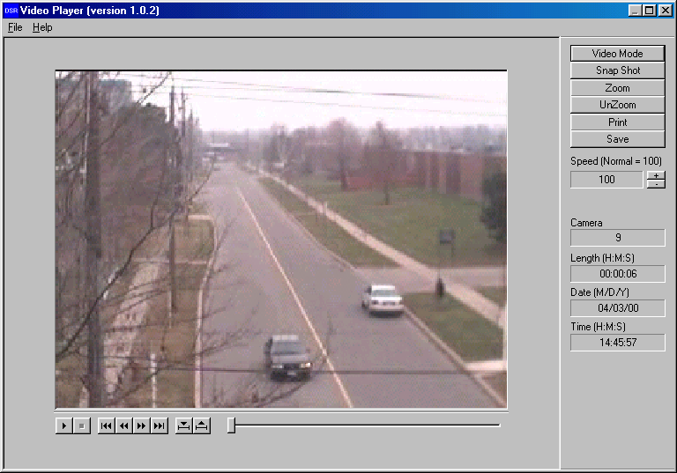
Camera Number
Speed control for playback
Frame operation
Back to video mode
Absolute Date/Time and length of the video
Scroll bar for manual search
Play
Stop
Steps advance and go to begin/end
Begin/end marker
Video playback controls | Use the video playback controls beneath the video image to control the video playback function.  - User can stop the video and use the scroll bar to search the video if needed.  - Press the “two-arrow” keys to advance one frame at a time.
Absolute date/time and video length display | The absolute date/time of the playback and the length of the video will be displayed on the control panel.
Playback speed control | Using the speed control box can control the playback speed. Click the “+” button to increase the playing speed. Click the “–“ button to decrease the playing speed. The playback speed indicates in the speed control box. The normal speed is at value 100.
Frame mode | Click “Snap shot” button to grab a frame from the video and enter the frame operation mode.
Zoom | User can select area of interest using mouse left button and mouse movement and then click “Zoom” button to zoom into the image. Click “Unzoom” to return to normal display.
Print hard copy | Click the “Print” button to print out the image captured.  Tip:  The user can set up printer properties for printing hard copy and preview the hard copy before actual printing.
Save a frame to floppy disk | The frame can be saved to floppy disk in drive A by a “Save” button click.  The saved filename has the following format:  x-mmddyy-hhmmss.bmp  x: camera number  mmddyy: month/day/year  hhmmss: hour:minute:second  bmp: bmp file extension
Return to Video mode | Click the “Video mode” button to go back to video playback mode.

Open a downloaded video file

Click the “file” and “Open” in menu bar of the DSR video player window to invoke the Open file dialog box.
Go to “c:\net_pico\image” to select the downloaded video files.
Select the video file and click “Open” to open and start playback.

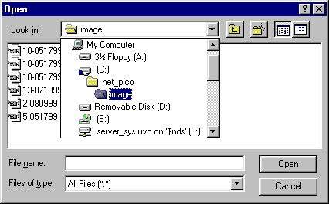

Open a locally (Client Station) recorded video file

Click the “file” and “Open” in menu bar of the DSR video player window to invoke the Open file dialog box.
Go to “c:\pico\image\{DSR station ID}\{camera title}” folder to select the recorded video files.
Select the video file and click “Open” to open and start playback.

Notes:
The example shows the folder C: \pico\image\pico_ntsc {DSR Station ID}\Camera 6{ camera title}. You may need to consult your DSR Network Administrator for details of camera title and Server station ID assignment.

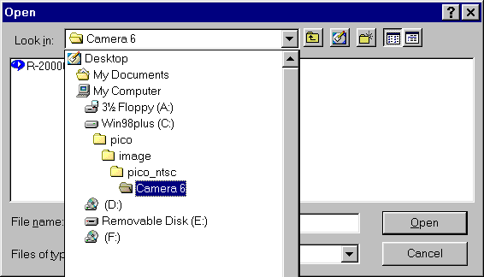

APPENDIX I

DSR Remote Player configuration

 | All data base and image files will be put inside the “c:\net_pico” default folder.
Database | The available video database will be downloaded to a file called “net_DSR.mdb”.  The “net_pico.mdb” is a database file with Microsoft Access format.
Video files | The selected video files will be downloaded to a default folder namely the “c:\net_pico\image” folder.
Housekeeping of the video files | User can playback, remove or backup of these downloaded video files inside the image folder.
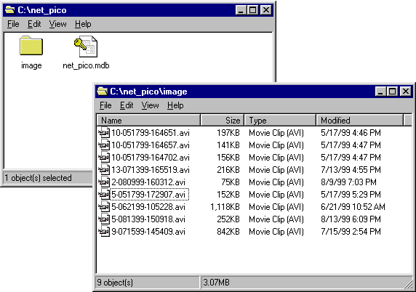

APPENDIX II

DSR Recorder configuration for remote playback and online viewing

The DSR recorder should be accessible through the LAN with the following configuration:
- It should have assigned with a computer name for the DSR recorder unit.
To check, right mouse click the “Network Neighborhood” icon on the Windows Explorer window and select “Properties”.
Select “Identification” tab to show the computer name.
- The “c:\pico” folder of the DSR recorder should be set to “Shared As”.
To check, right mouse click the “c:\pico” folder on the Windows Explorer window and select “Properties”.
Select “Sharing” tab and check the “Shared As” button.
There will be a hand holding the “c:\pixo” folder icon to indicate sharing of the folder.

DSR
Station #3
DSR
Station #1
DSR
Station #2
Client #1
Client #2
Modem
Modem
PSTN
LAN

