执 H,酬 c.
Signal Hill, California
Model

DLA_D
Pat. No. 5,635,058
MADE IN USA
Reverse Osmosis

DRAIN LINE ADAPTER
► For Disposal C〇f*n〇(；ti〇n witfi or without
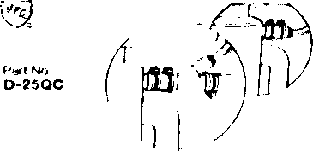
(C< C〇pyr»〇^* 2〇<〇

