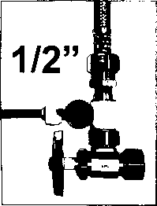
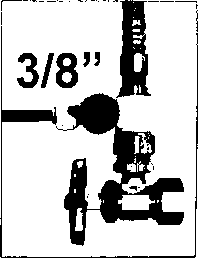
2. As shown above, this adapter connection can be used for both 3/8"or 1/2” feed line plumbing.
Simply by switching the adapter nut like below (PART A) from one side of the adapter valve to the other.
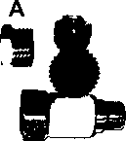

NOTE!
DO NOT USE TEFLON TAPE
(HAND TIGHTEN OR USE WRENCH)
DO NOT OVER TIGHTEN

WARNING!

WATER PRESSURE SHOULD NOT EXCEED 80 PSI

