INSTALLATION STEP 4

LEAK DETECTOR


1.
POSITION THE SYSTEM TO THE DESIRED
PERMANENT LOCATION
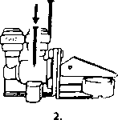
POSITION THE LEAK DETECTOR IN THE SAME
CABINET NEAR THE SYSTEM AND
SCREW ITTOTHE FLOOR
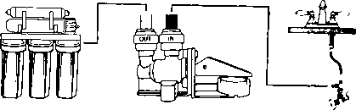
3.
CONNECT THE RED TUBE INTO THE FEED ADAPTER AND INTO THE INLET (IN) OF
THE LEAK DETECTOR. CONNECT THE WHITE TUBE INTO THE OUTLET (OUT) OF THE
LEAK DETECTOR AND INTO THE 1ST STAGE OF THE RO SYSTEM (INLET)
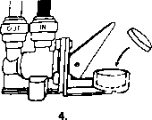
TAKE OFF THE WRAP AND
PLACE THE COMPRESSED TEXTILE
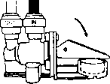
5.
TURN THE SWITCH DOWN, AND THE LEAK
DETECTOR IS READYTO BE USED
Note! Please avoid contact of any liquid to the compressed textile.
Failure to do so will activate the textile and shut the incoming water.

