INSTALLATION STEP 7

RO TANK ASSEMBLY

NOTE!
Do not tamper with the air valve on low side of storage tank.
It has been preset at 7-10 psi by the manufacturer.
- Open the box and remove the stand from the top of the tank.
- Wrap the thread 6-8 times with plumbers (Teflon) tape only.
- Connect the ball valve to the thread. Make sure it is tight but not overly tight.
- Place the storage tank in desire location. Since it is the pressure storage tank, it can stand up straight or lie down.
- Connect the (yellow) tubing from inline filter (5th stage) to the tank ball valve. (See 5-Stage RO system diagram page 6)
- Turn the tank ball valve on.
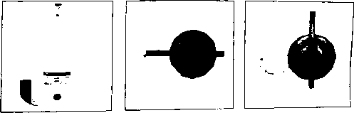

ON POSITION

OFF POSITION

