SYSTEM CONNECTIONS
Long Reach
Drinking Faucet
1 /4" Yellow tubing to tank
1/4* Blue tubing | to faucet I
Carbon Final Filter Cth
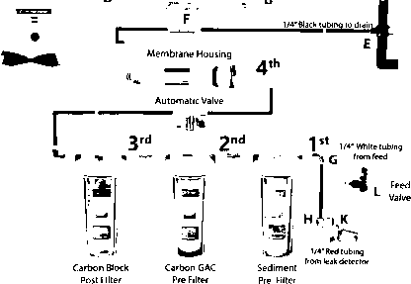
- L to K. Connect the white tube into the feed adapter (point L) and to the inlet marked as "in" of the leak detector (point K)
- G to H. Connect the red colored tubing to first stage housing (point G) to the outlet marked as "out" of the leak detector (point H)
- A to B. Connect the yellow tubing from the storage-tank (point A) to the post carbon inline tee (point B).
- C to D. Connect the blue tubing from the faucet (point C) to the end of the post inline carbon marked as "to faucet" (point D).
- E to F. Connect the black colored tubing from the Drain Saddle Valve (point F) to the Flow Restrictor marked as "to drain" (point E).

