ITEMIZATION OF
COMPONENTS
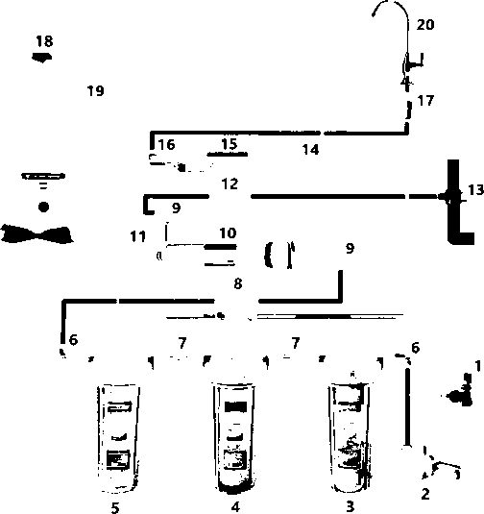
- Feed Water Adapter
- Leak Detector
- Sediment Water Filter
- GAC Carbon Filter
- Carbon Block Filter
- Male Elbow 1/4“
- Nipple
- Automatic Shut-Off Valve
- Male Elbow 1/8〃
- RO Membrane Housing
- Check Valve
- Drain Flow Restrictor
- Drain Saddle
- Stem Tee
- Inline Granular Carbon Post Filter
- Stem Elbow
- Quick-Connect Faucet Connector
- Tank Valve
- Tank
- Faucet

System Filters

_


y

l\

