QUICK CONNECT GUIDE
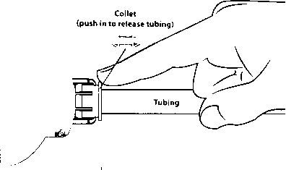
TO ATTACH TUBING TO RELEASE TUBING
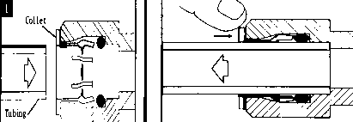
Pushing strap in as farasrtwill go. Push in collet to release tubing.
■ — TO INSERT LOCKING CLIP

0 r
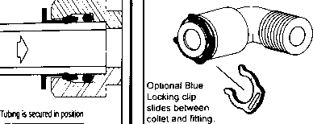
CAUTION: When cutting supplied tubes, predetermine the length by measuring the distance between the components to be connected.

