INSTALLATION STEP 2

ELBOW FITTING CONNECTION
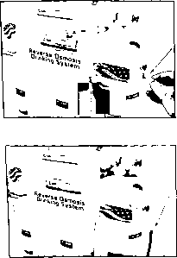
Screw the elbow fitting into the end of the
right filter housing (in) until tightened and
(the insert) is facing at a downward angle.
Fully insert the red tubing into the fitting.
Apply force while pushing tube into fitting
to ensure the quick connect has locked.
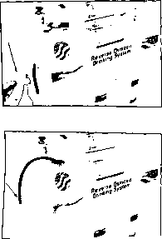
Screw the elbow fitting into the end of the
left filter housing (out) until tightened and
(the insert) is facing at a 11 CTCIock degree.
Fully insert the red tubing into the fitting.
Apply force while pushing tube into fitting
to ensure the quick connect has locked.

