.^{D,sconnect} ^ power supply to
the disposal by unplugging the cord
under the sink, or shutting off the
circurt breaker before starting work
(Do thts for Configuration A & B)
2 • Remove dishwasher drair, hose
from d/sposal by unscrewing hose
clamp, or expanding spring damp with
P*»ers. Move clamp away from disposal nipple, then twist
hose back and forth while pulling away from disposal to
separate. (See Rg. 1)
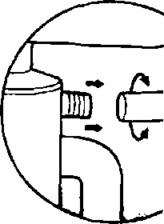
3. Universal barbs on (he
DLA-D will accommodate
the various dishwasher hoses
encountered. Determine which
size is required by sliding open
erxi of hose over stepped
barbs until on© fits snugfy. If the
hose fits snug(y over the middle
or largest bart», you must cut
away the smaBer barb(s) with
a hacksaw. Use the grooved
"cut lines" provided, then
smooth away any burrs
(See F/g. 2a)
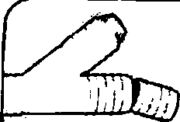
F


