O. Point arrows of DLA-D toward disposal and sftde bartss
into remaining one inch of hose coopter unti firmjy seated against disposal nipp*e. Onent the "wye branch" »n a vertical position to receive Fi〇 drain tube, 了igfiten botfi hose clamps securely over hose coupler so ttiat the DLA-0 is sofafly mounted on dtsposa). (See Fig. 2d)
setected barb. (See Rg. 3)
8. Cut off excess hose squarely wrth a sharp knrte. Reuse
oogmai spnng or hose type cJamo Dy sUcShq toosetv hose.
horizontal, and position semi-taut hose beh*nd tf. Take a measurement on the hose against the

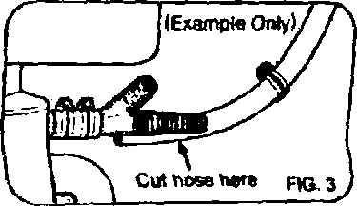
fSee Ftg. 3)

